**Veer Narmad South Gujarat University,**

**Surat.**

**Department of Information and**

**Communication Technology**

**M.Sc. (Information Technology)**

**5 Year Integrated Course**

**Year 2022 – 2023**

**B.Sc. (Information Technology)**

**6th Semester**

# **Project Report**

## Online Shopping Website

|  |  |
| --- | --- |
| **Guided By** | **Submitted By** |
| **Internal Guide:** | Fenil Munjani  SPID: 20200 |
| Dr. Shailesh Chaudhary | Viraj Talaviya  SPID: 2020049932 |
|  |  |
|  |  |





### The reason of completing the project work successfully is not just our efforts but efforts of many people. The people, who trusted us, guided us and encouraged us with every means. Guide is a person who provides you the direction towards success, so I feel great pleasure to express our gratitude to our guides, our faculty members as well as every person who helped us directly or indirectly with our project.

We are also indebted to our Professor **Dr. Shailesh chaudhary** who provided constant encouragement, support & valuable guidance before and during our project. It was his effort who led us to this place for project work. His guidance and suggestions were valuable.

Thank you very much,

**Fenil Munjani**

**Viraj Talaviya,**

**Preface**

Before Tasking the Project Work for Foundation, It Is Quite Necessary to Have an Exact Idea The Work “**Project**”. The Project Consist of Seven Letters Each Letter Has Its Own Significance as Follow:

**‘P’** For Planning

**‘R’** For Resources

**‘O’** For Operation

### **‘J’** For Joints Efforts

**‘E’** For Engineering Function

**‘C’** Communication

**‘T’** Task of Working

### We Happy to Hand Over This Project to The **J.P Dawar institute of Information and Technology**.Avenue fashion is useful for those purchasers who have a keen interest in Online purchasing.

Doing this project helped us to enhance our knowledge regarding the Online E-commerce website. we do undergo many experiences related with our topic. Through this project we come to know about importance of teamwork and role of devotion the work.

This Website is capable enough to save time of Users. Avenue fashion is not only replace paperwork. It give reliability, flexibility and robustness to website by modern computer technology.

**Index**

|  |  |  |
| --- | --- | --- |
| **Serial**  **No.** | **Topic** | **Page No.** |
| **01.** | **Introduction** | 7 |
|  | * 1. College Profile   2. Project Profile | 8 |
| **02.** | **Proposed System** | 10 |
|  | 2.1 Scope & Objective | 10 |
| 2.2 Advantages | 11 |
| 2.3 Feasibility Study | 11 |
| 2.3.1 Technical Feasibility | 12 |
| 2.3.2 Economical Feasibility | 12 |
| 2.3.3 Operational Feasibility | 12 |
| **03.** | **System Analysis** | 14 |
|  | 3.1 Existing System * (If Available) | 14 |
| 3.2 Need For New System | 15 |
| 3.3 Detailed SRS(Software Requirement Specification) | 15 |
| **04.** | **System Planning** | 17 |
|  | 4.1 Requirement Analysis & Data Gathering | 17 |
| **05.** | **Tools & Environment Used** | 19 |
|  | 5.1 Hardware and Software Requirement | 20 |
| 5.1.1 Software Requirement | 20 |
| 5.1.2 Hardware Requirement | 20 |
| 5.2 Server-Side and Client-side Tools | 21 |
| **06.** | **System Design** | 22 |
|  | 6.1 Unified Modeling Language (UML) -> Activity, Use case, Class, Sequence | 23 |
| * 1. Database Design | 38 |
| 6.2.1 Data Dictionary | 38 |
| 6.3 E-R Diagram | 44 |
| 6. 4 User Interface Design (Screen Layout) | 45 |
| **07.** | **System Testing (Any Testing According to Project)** | 83 |
| **08.** | **Future Enhancement** | 85 |
| **09.** | **References** | 87 |



**Introduction**

# INTRODUCTION

## **College Profile**

J P Dawar institute of Information and Technology, Surat a highly commendable institute, occupies a place amongst the technical institutes of the southern region of Gujarat. It is established in year 2000, financed and run by the Veer Narmad South Gujarat University, Surat.

The Department of ICT has excelled itself in many fields. It has occupied a prominent place in the education sphere of South Gujarat. The building surrounded by green fields and contains spacious classrooms, well documented library, modern computer lab. It has at present around 150 students in B.sc IT semester-6.

#### **Vision**

In 21st century, IT technology has been growing in every area of business & society, while in competitive environment it is our vision to make the students more efficient in the field of Information Technology, which will help students to become more efficient skill oriented professional and ready to grab opportunities in the said field.

#### **Mission**

Our mission is to provide learning experience through renowned educational institution which shall expose the students in computer application in day-to-day life. Imparting quality undergraduate education in the arena of Computer Application through well designed curriculum and train students to apply this education for life- long high-quality careers and give them competitive benefit in the ever-changing and challenging global work environment of 21st century.

**1.2 Project Profile**

|  |  |
| --- | --- |
| Project Title | AVENUE FASHION |
| Project Definition | A platform by which users can fulfill Their demands. Easily accessible and buy clothes online. |
| Framework | JavaScript |
| Type of Application | Website |
| Duration | 2 months |
| Internal Guide | Dr. Shailesh Chaudhary |
| Front End | PHP |
| Back End | MySQL |
| Language | Bootstrap, JavaScript, jQuery, CSS, HTML |
| Operating System | Windows 10/11 |
| Submitted By | Fenil Munjani  Viraj Talaviya |



**PROPOSED SYSTEM**

**2. PROPOSED SYSTEM**

* 1. **Scope & Objective**
* **Scope:**

This “AVENUE FASHION” will be E-Commerce website which consists of the admin and user. The Customer will login and select the category of which they need to buy Product after that admin will give the information of the Product to the user. The admin will allocate cart to the user for adding product and order.

* + User will have to register with the basic information.
  + User must have a valid Username and password to login to the website.
  + Admin can allocate product to customer.
  + Admin can also add new category to the new items.
  + Admin can also manage the orders of the new products.
  + Admin can also add the category of the existing or new stock that have been allocated to buyer.
  + User can see the order that they have purchased.
* **Objective:**

The objectives of our E-commerce website that can be known by The Avenue fashion are as follows:

* The main objective of the AVENUE FASHION is discipline of the organizing, satisfaction and managing the product and orders.
* Our project aims at making the task of shopping easy.
* Provide environment to conduct for online shopping.
* Maintains all information regarding the customer and their product and order results.
* Provide an online outlet by which user might do shopping easily.
* Customer may checkout with couple of payment processes.
  1. **Advantages**
* **Benefits to User:**
* Faster buying process
* Store and product listing creation
* Cost reduction
* Product and price comparison
* Faster response to buyer/market demands
* Several payment modes
* Enables easy exports
  1. **Feasibility Study**

When we are developing the system (software), we must know the proposed system will be feasible or i.e., practically implemented or not it may possible the proposed system may not implement due to many reasons like it may take long time in development than the specified time limit, cost may increase than proposed one, etc. Therefore, we must analyze the feasibility of the system.

Feasibility is the analysis of risks, costs & benefits relating to economics, technology & user operation.

There are several types of feasibility depending on the aspect they cover. Some important feasibility is as follows: -

* + - * Technical Feasibility
      * Operational Feasibility
      * Economic Feasibility
    1. **Technical feasibility**

The technically feasibility study basically centers on alternatives for hardware, software and design approach to determine the functional aspects of system.

The web-application has been developed with PHP and SQL server as backend tools.

SQL Server will be used for storing data. Hardware requirements used are compatible with all O.S. Only authorized person would be able to use the website so it would be secure. The system can also be expanded as per the needs of requirement specification.

* + 1. **Operational Feasibility**

Operational Feasibility is a measure of how people can work with system.

This type of feasibility demands if the system will work when developed and installed. Since website is very user friendly so users will find it comfortable to work on this site.

* + 1. **Economic Feasibility**

Economic analysis is the most frequently used evaluating the effectiveness of proposed system, more commonly known as Benefit analysis. The Benefit analysis is to determine benefits and savings which are expected from candidate system and compare them with cost.

If the benefits are more than the cost, then decision is made to design and implement the system. The cost and benefits may be direct or indirect and tangible or intangible.



**SYSTEM ANALYSIS**

1. **SYSTEM ANALYSIS**

System Analysis is an investigation into a problem and how a new system will solve it. It is the most essential part of the development of a project of a system analysis. System analysis consists of system element, process and technology.

System analysis includes the following basic concepts:

* Preliminary investigation
* Requirements specification
* Feasibility study
* Detailed investigation
* Drawing up of strategies
* Design and coding
* Testing and training
* Implementation
  1. **Existing System**

As mentioned existing system is manual, the system holds Paper-Work. Faculty has to create paper manual and have to refer old question paper by hard copy. This procedure need more paper work, also takes time to review question paper and show it to principal.

Moreover, it has all the disadvantage of being a manual system like,

* + - Time Consuming.
    - Increased Paper Work.
    - Difficult To Maintain Record.
    - Require lots of Human Effort.
    - Chances to be leak.
  1. **Need For New System**

To solve the problems as they required a computerized system to handle all the works. They required a web-based application that will provide a working environment that will be flexible and will provide ease of work and will reduce the time for report generation and other paper works.

* 1. **Detailed SRS**
* Administrator can add, edit and delete Product, Category, Size, Color.
* Admin will provide other users password by sending them mail.

It should:

* Look professional / corporate.
* Maintain a clean look and feel throughout.
* Be easy for all user types to use and navigate.
* Users can use one or facilities like selecting Website, looking to Product, and to prospectus details.
* The primary goal is to allow users to have an interactive real time session without their browser constantly refreshing. At the same time, all contents and information need to be captured into a database.

Ideally this site should be completely database driven.



**SYSTEM PLANNING**

# **SYSTEM PLANNING**

Before staring a software project, it is to determine the tasks to be performed and properly manage allocation of tasks among individuals involved in the software development. Hence, planning is important as it results in effective software development.

Project planning is an organized and integrated management process, which focuses on activities required for successful completion of the project. It prevents obstacles that arise in the project such as changes in projects or organization's objectives, non-availability of resources, and so on. Project planning also helps in better utilization of resources and optimal usage of the allotted time for a project.

The other objectives of project planning are listed below.

* It defines the roles and responsibilities of the project management team members.
* It ensures that the project management team works according to the business objectives.
* It checks feasibility of the schedule and user requirements.
* It determines project constraints

## **Requirement Analysis and Data Gathering**

This project is for the online shopping and fulfill the requirments of customer demand about items and services.

Success of any system depends mostly on how well data/Requirement gathering are done. It provides direction to system analyst and designers to design a system that is efficient.

To gather requirement for online shopping system, following steps were carried out:

* + - We referred similar website to get an idea of how website should look a like.
    - We also took help from our classmate, faculty and principal to resolve some errors.
    - We also consult senior Project for technical problems.
    - We also visit to website for system.



**TOOLS & ENVIROMENT USED**

1. **TOOLS & ENVIRONMENT USED**

## **Hardware and Software Specification**

* + 1. **Software Specification**

Given below is recommended specification of require software to develop the system:

|  |  |
| --- | --- |
| **Operating System** | Microsoft Windows 11 |
| **Front End** | PHP |
| **Back End** | MySQL |
| **Input Device** | Keyboard, Mouse |
| **Output Device** | Monitor |

## **Hardware Specification**

Given below is recommended hardware specification that required at client side to run software:

|  |  |
| --- | --- |
| **Processor** | : Processor Intel(R) Core™ i37020U CPU @  2.30GHz |
| **Memory** | : 8 GB of RAM |
| **Hard Disk** | : 1TB |
| **Operating System** | : Microsoft Windows 10 or 11 |

## **5.2 Server Side and Client-Side Tool**

#### **Overview Of PHP:**

Precisely, PHP Is a Very Powerful Server-Side Scripting Language Like ASP For Developing Dynamic Web Applications. Using PHP, You Can Build Interactive and Dynamic Websites with Ease. If You Have Some Idea About the C Language Then Learning PHP Should Be a Fairly Simple Task for You.

It Is Free, It Is Suitable for Web Development, It Is Efficient, It Is Widely Used and It Is Considered to Be the Most Powerful Alternative to Microsoft’s ASP. PHP Script Can Be Embedded Straight into The Heart of Html Code Just Like ASP.

One of the Reason of the why PHP is getting more Popular is that its syntax is Very Much Similar to That of C And Perl. PHP Is Compatible with Various Web Servers like Apache and the Microsoft’s IIS As Well. All the PHP Scripts Are Executed on the Server (Apache, IIS Etc.) And It Supports Various Databases Like MySQL, Oracle, Solid, Generic ODBC Etc.;

However, It is mostly used with MySQL. Another reason for increasing popularity of php is that it is free to download and use. What does a PHP file contais is a common question asked by many PHP leaners. A PHP file has an extension of .php or .php3 and it may contain various HTML tags, texts, and scripts. Although PHP file contains scripts but when it is returned to the browser, it is returned as a plain HTML file.



**SYSTEM DESIGN**

1. **SYSTEM DESIGN**

System designing in terms of software engineering has its own value and importance in the system development process as a whole. To mention it may though seem as simple as anything or simply the design of systems, but in a broader sense it implies a systematic and rigorous approach to design such a system which fulfills all the practical aspects including flexibility, efficiency and security.

Systems design is the process of defining the architecture, components, modules, interfaces, and data for a system to satisfy specified requirements. System design could be seen as the application of systems theory to product development.

## **6.1 Unified Modelling Languag(UML):**

## **What is UML?**

* UML stands for Unified Modelling Language. The object-oriented system of notation has evolved from the work of Grady Brooch, James Rumbaugh, Invar Jacobson and the Rational Software Corporation.
* These renowned computer scientists fused their respective technologies into a single standardized model.
* Today, UML is accepted by the Object Management Group (OMG) as the standard for modelling object-oriented programs.
* UML defines nine components of diagrams. They are as follows:
  + - Class
    - Object
    - Use case
    - Sequence
    - Collaboration
    - State chart
    - Activity
    - Component
    - Deployment
    1. **Use Case Diagram**

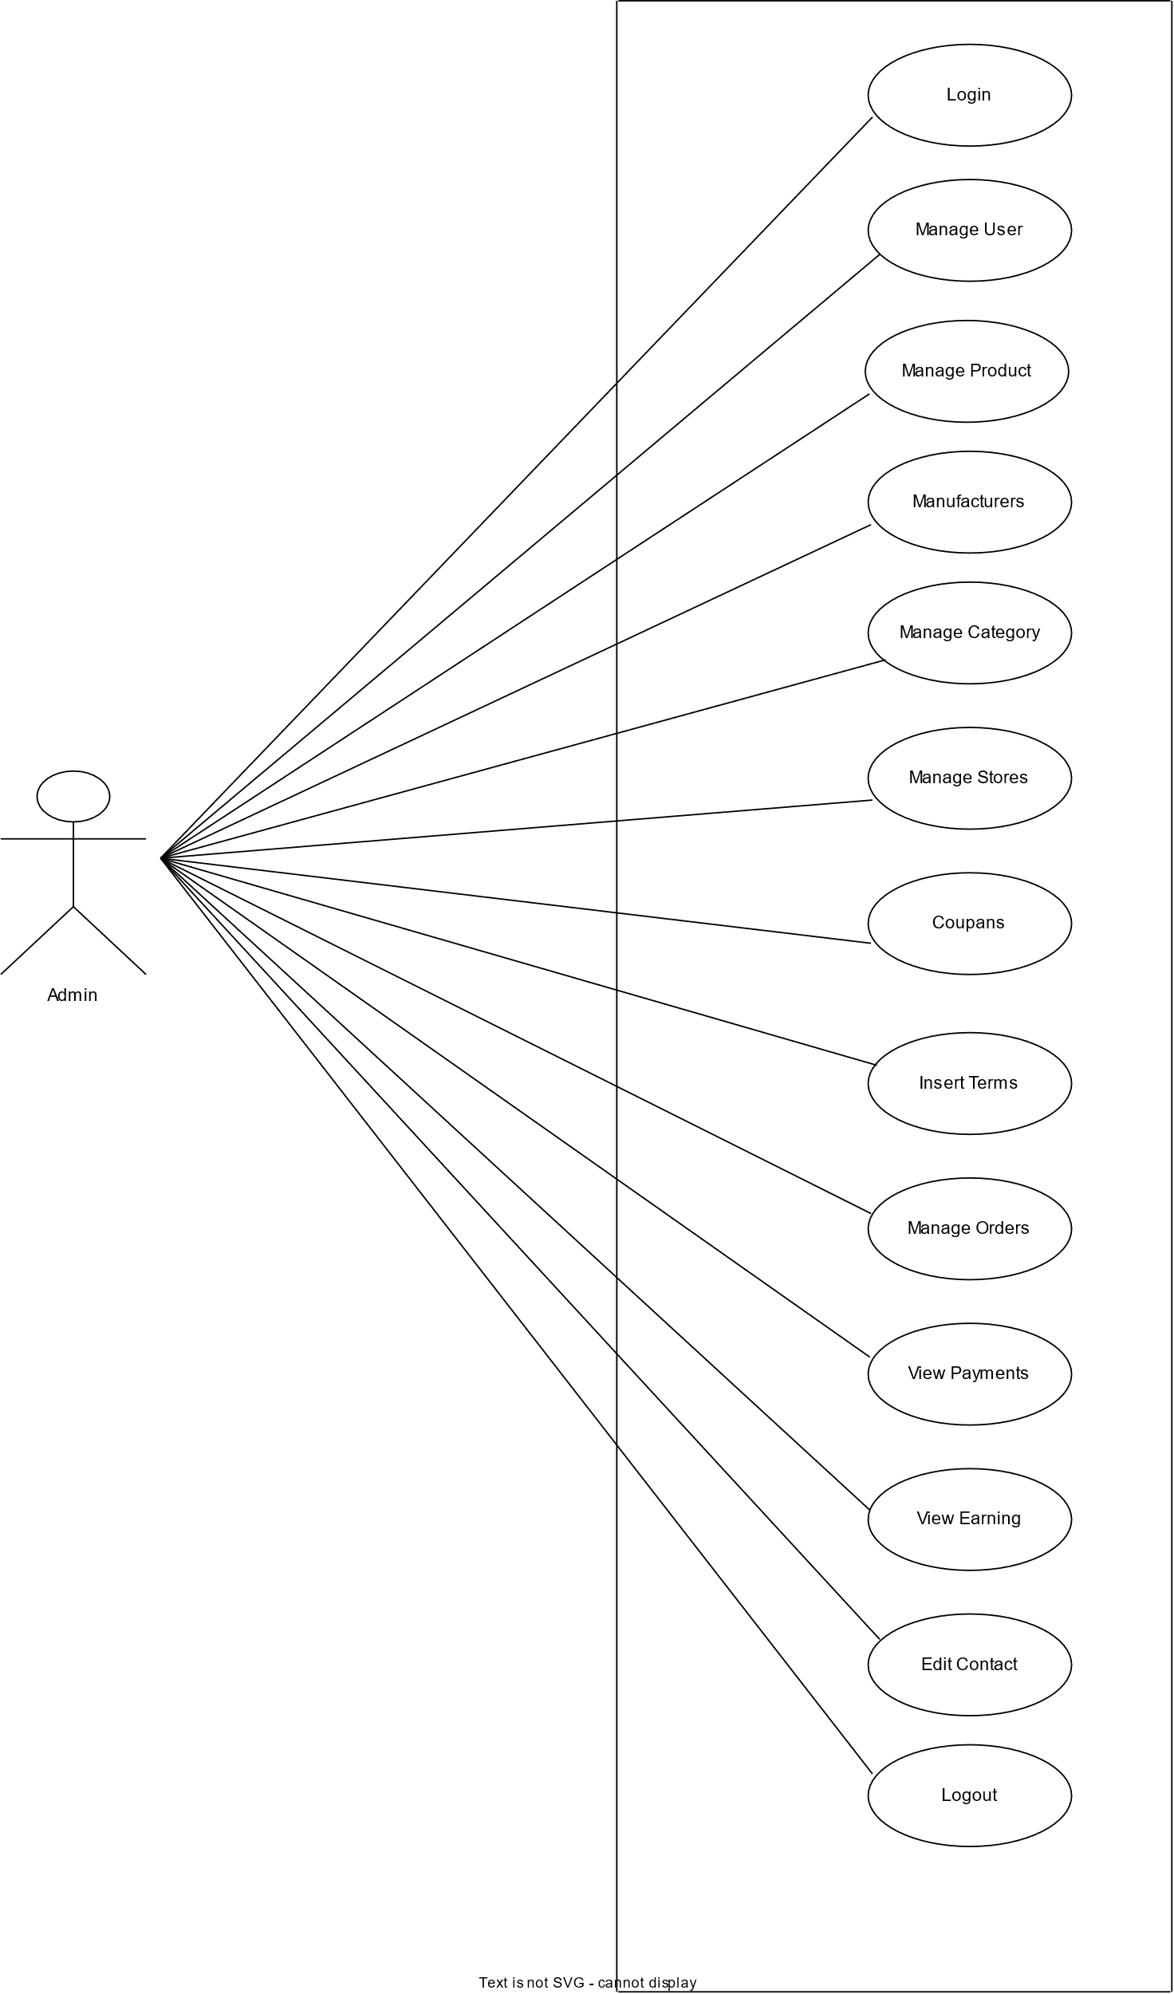

**[UML Use Case Diagram of Admin]**

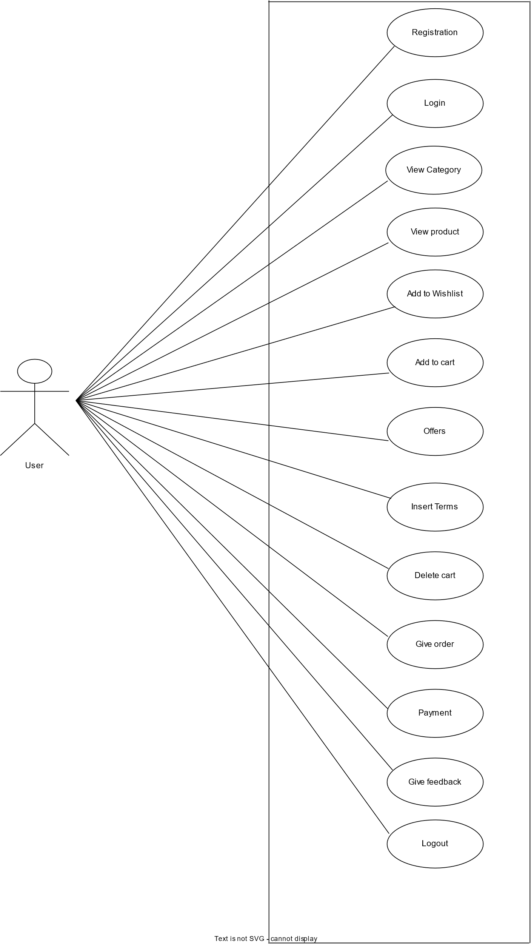

**[UML Use Case Diagram of User]**

* + 1. **Activity Diagram**

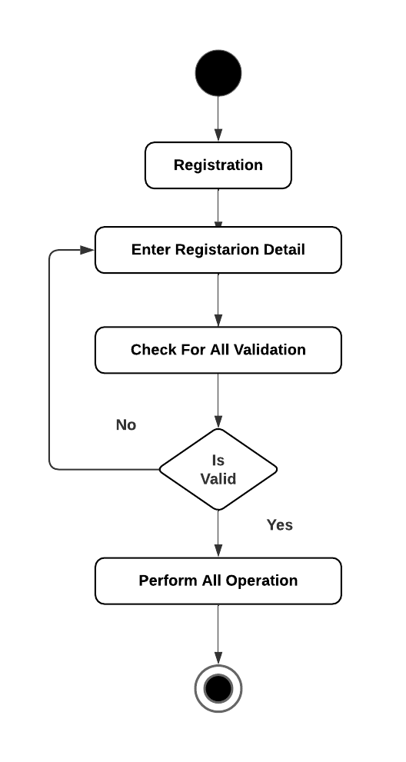

**[UML Activity Diagram of Registration]**

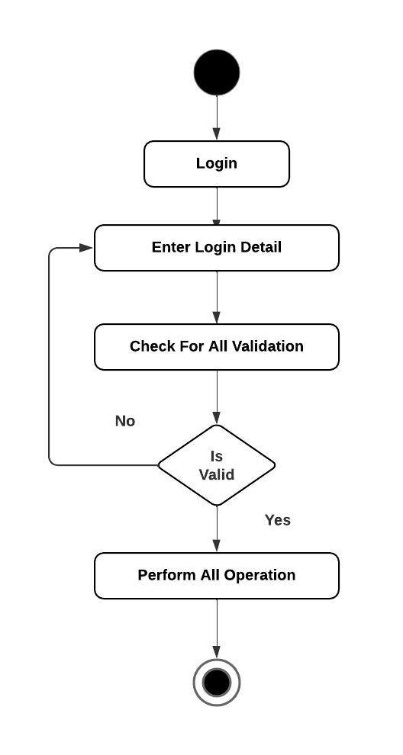

**[UML Activity Diagram of Login]**

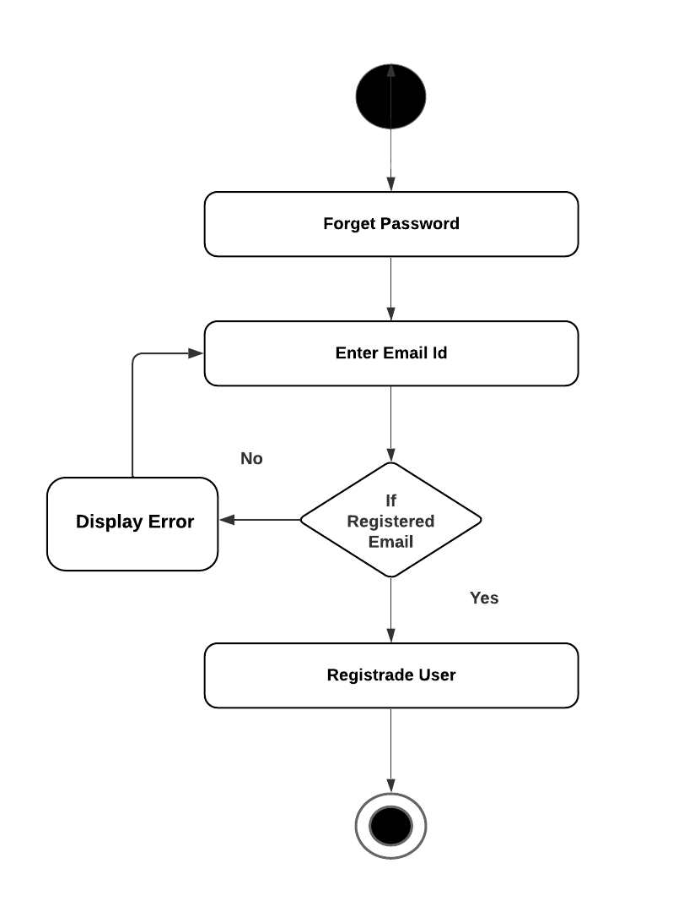

**[UML Activity Diagram of Forget Password]**

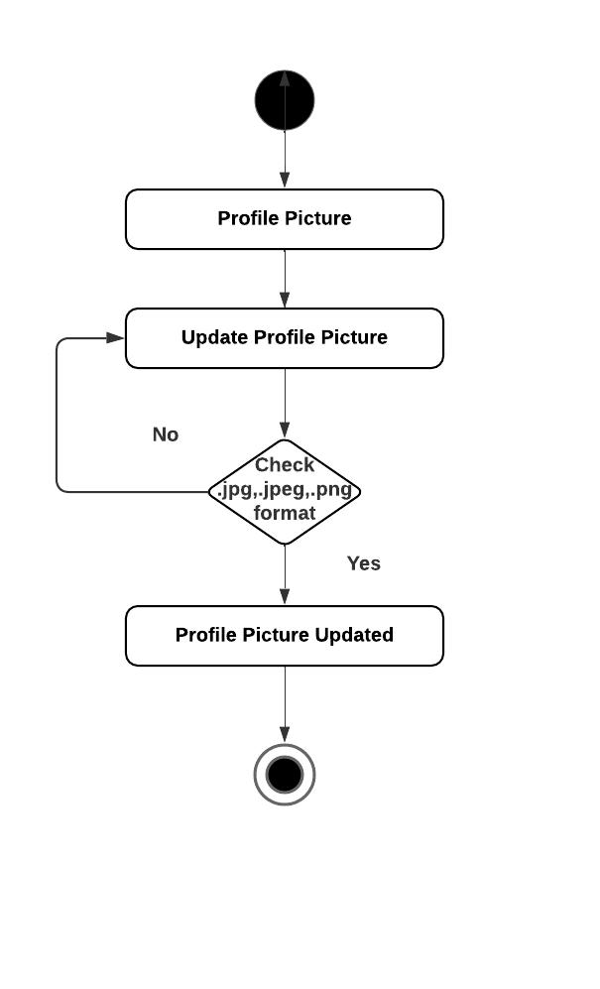

**[UML Activity Diagram of Update Picture]**

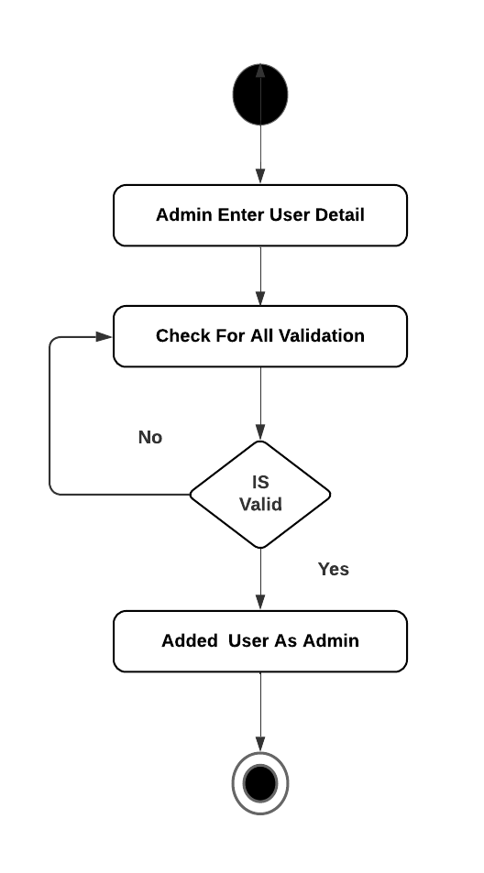

**[UML Activity Diagram of Add User as a Admin]**

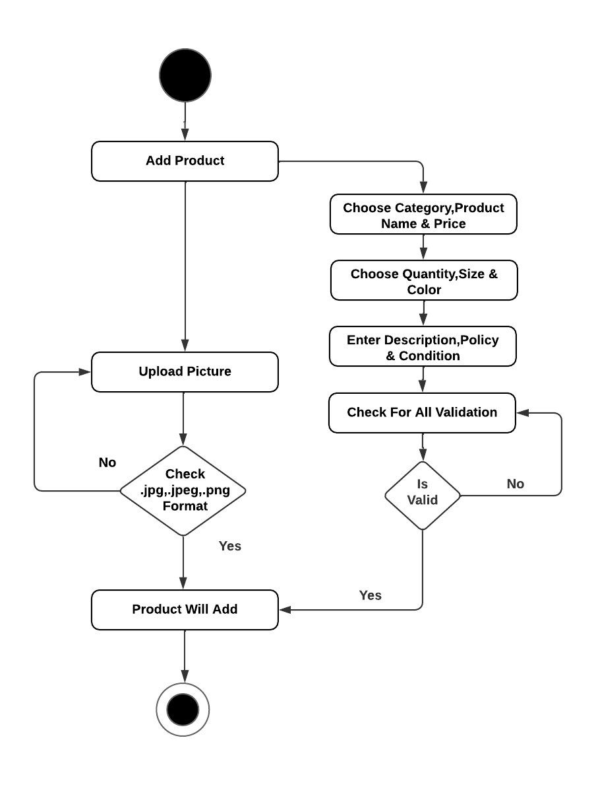

**[UML Activity Diagram of add New Product]**

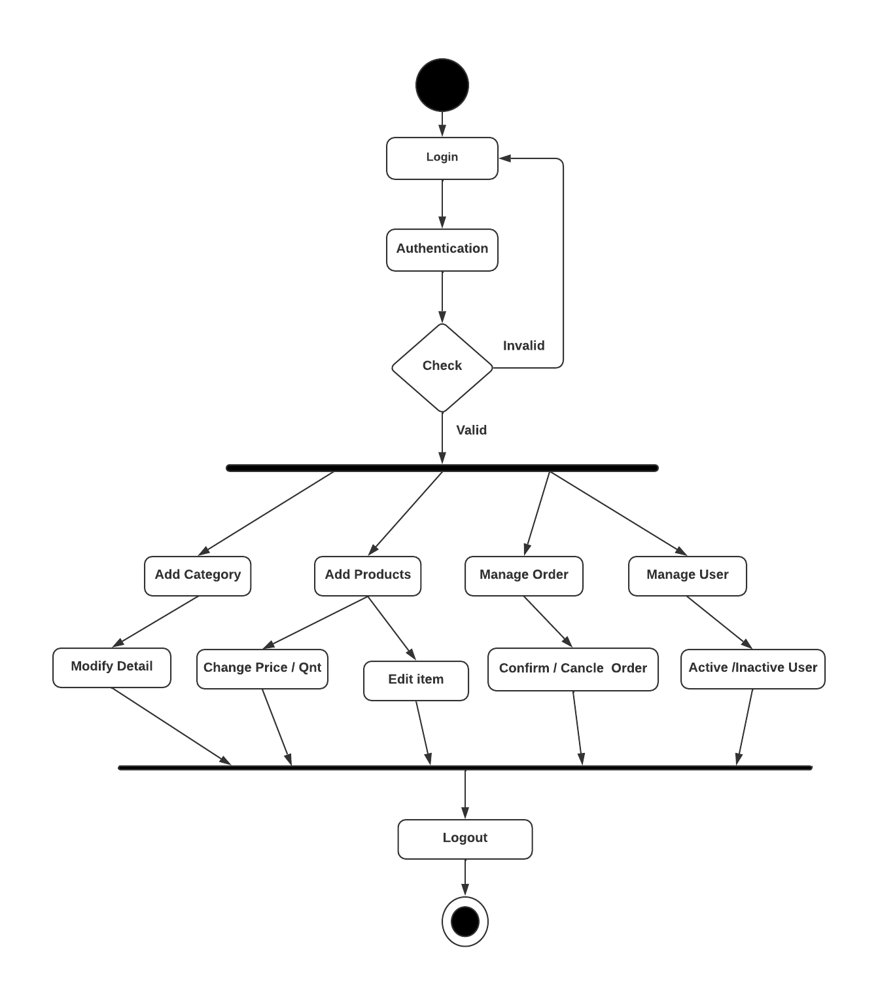

**[UML Activity Diagram of Admin Management]**

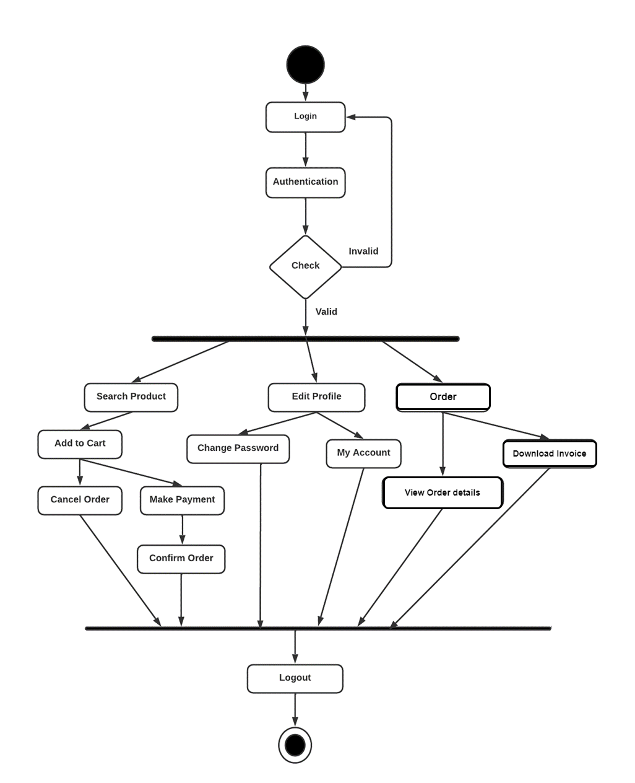

**[UML Activity Diagram of User Management]**

* + 1. **Class Diagram:**

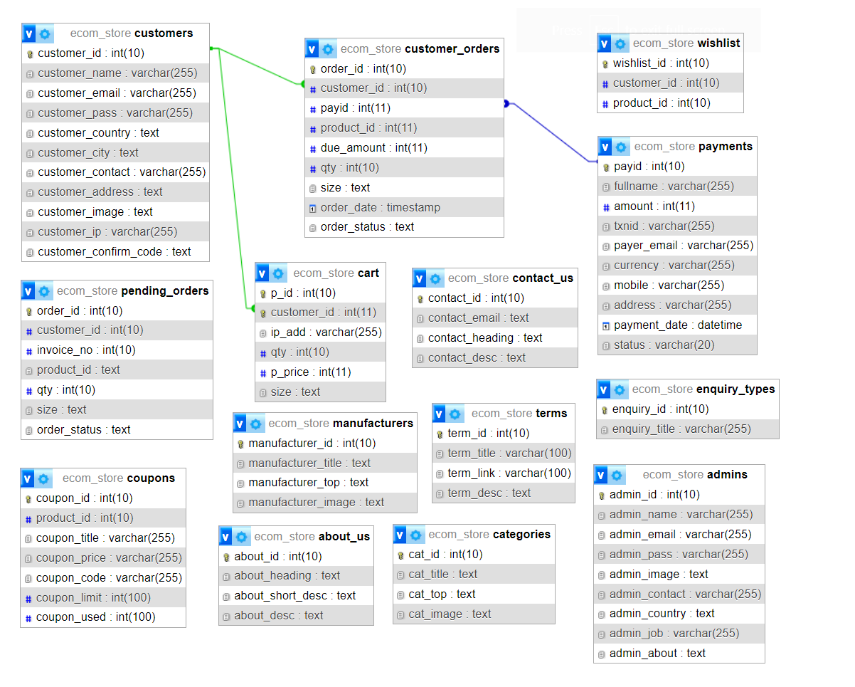

* + 1. **Sequence Diagram:**

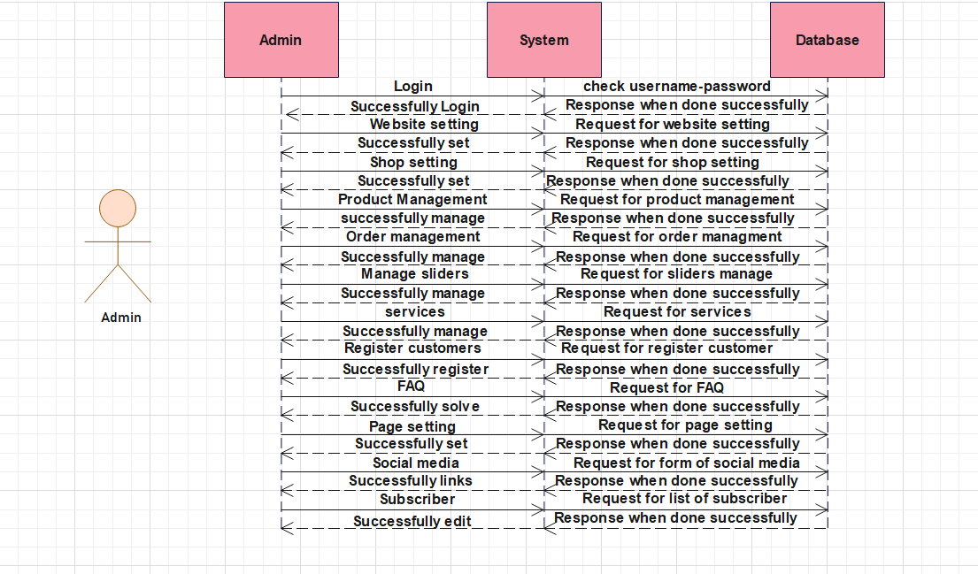

**[UML Sequence Diagram of Admin]**

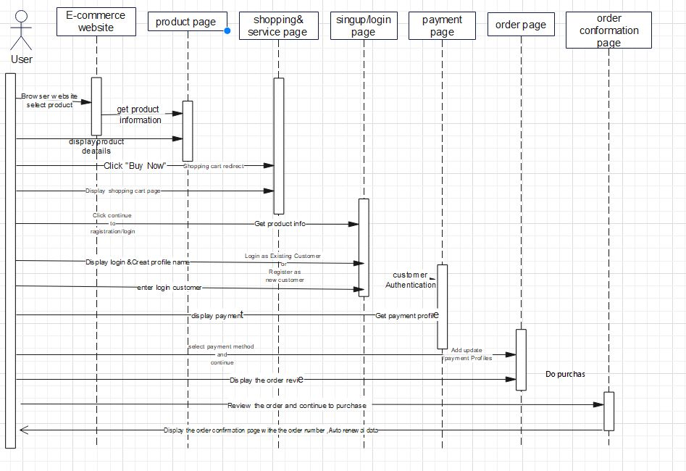

**[UML Sequence Diagram of User]**

* 1. **Database Design**

**6.2.1. Data Dictionary**

1. **Customers**

|  |  |  |  |
| --- | --- | --- | --- |
| Column Name | Data type | Constraints | Description |
| Customer_id | int | Primary key | Auto increment |
| Customer_name | varchar | Not null | Customer Name |
| Customer_email | Varchar | Not null | Customer email |
| Customer_pass | Varchar | Not null | Customer Password |
| Customer_country | Varchar | Not null | Customer country |
| Customer_city | Varchar | Not null | Customer city |
| Customer_contact | Varchar | Not null | Customer contact |
| Customer_address | text | Not null | Customer address |
| Customer_image | text | Not null | Customer image |
| Customer_ip | Varchar | Not null | Customer IP |
| Customer_confirm_code | text | Not null | Confirm code |

1. **about us**

|  |  |  |  |
| --- | --- | --- | --- |
| Column Name | Data type | Constraints | Description |
| about_id | int | Primary key | Auto Increment |
| about_heading | text | Not null | heading of about |
| about_short_desc | text | Not null | about short description |
| about_desc | text | Not null | About description |

1. **admins**

|  |  |  |  |
| --- | --- | --- | --- |
| Column Name | Data type | Constraints | Description |
| admin_id | int | Primary key | Auto Increment |
| admin_name | text | Not null | Admin name |
| admin_email | text | Not null | Admin email |
| admin_pass | text | Not null | Admin password |
| admin_img | int | Not null | Admin image |
| admin_contact | text | Not null | Admin contact |
| admin_country | text | Not null | Admin country |
| admin_job | varchar | Not null | Admin job |
| admin_about | text | Not null | Admin about |

1. **cart**

|  |  |  |  |
| --- | --- | --- | --- |
| Column Name | Data type | Constraints | Description |
| P_id | int | Primary key | Auto Increment |
| customer_id | int | Primary key | Customer id |
| ip_add | Varchar | Not null | IP address |
| qty | Int | Not null | Quantity |
| p_price | Int | Not null | Product price |
| size | text | Not null | Size of product |

1. **categories**

|  |  |  |  |
| --- | --- | --- | --- |
| Column Name | Data type | Constraints | Description |
| Cat_id | int | Primary key | Auto Increment |
| cat_title | text | Not null | Category title |
| cat_top | text | Not null | Yes or no |
| cat_image | text | Not null | Category image |

1. **contact_us**

|  |  |  |  |
| --- | --- | --- | --- |
| Column Name | Data type | Constraints | Description |
| contact_id | int | Primary key | Auto Increment |
| contact_email | Varchar | Not null | Contact email |
| contact_heading | text | Not null | Contact heding |
| contact_desc | text | Not null | Contact description |

1. **coupons**

|  |  |  |  |
| --- | --- | --- | --- |
| Column Name | Data type | Constraints | Description |
| coupan_id | int | Primary key | Auto Increment |
| product_id | Int | Not null | Product id |
| coupan_title | Varchar | Not null | Coupan title |
| coupan_price | Varchar | Not null | Coupan price |
| coupan_code | Varchar | Not null | Coupan code |
| coupan_limit | Int | Not null | Coupan limit |
| coupan_used | Int | Not null | Coupan used |

1. **customer_orders**

|  |  |  |  |
| --- | --- | --- | --- |
| Column Name | Data type | Constraints | Description |
| order_id | int | Primary key | Auto Increment |
| customer_id | Int | Foreign key | Customer id |
| payid | Int | Foreign key | Payment id |
| product_id | Int | Foreign key | Product id |
| due_amount | Int | Not null | Due amount |
| Qty | Int | Not null | Quantity |
| Size | text | Not null | Size of product |
| Order_date | Timestamp | Not null | Order date |
| Order_status | text | Not null | Order status |

1. **enquiry types**

|  |  |  |  |
| --- | --- | --- | --- |
| Column Name | Data type | Constraints | Description |
| enquiry_id | int | Primary key | Auto Increment |
| enquiry_title | Varchar | Not null | Enquiry title |

1. **manufacturer**

|  |  |  |  |
| --- | --- | --- | --- |
| Column Name | Data type | Constraints | Description |
| manufacturer_id | int | Primary key | Auto Increment |
| manufacturer_title | text | Not null | Manufacturer title |
| manufacturer_top | text | Not null | Manufacturer top |
| manufacturer_image | text | Not null | Manufacturer image |

1. **paymnts**

|  |  |  |  |
| --- | --- | --- | --- |
| Column Name | Data type | Constraints | Description |
| pay_id | int | Primary key | Auto Increment |
| fullname | Varchar | Not null | Full name |
| amount | Int | Not null | Amount |
| txnid | Varchar | Not null | Transaction id |
| payer_email | Varchar | Not null | Payer email |
| currency | Varchar | Not null | Currency |
| mobile | Varchar | Not null | Mobile number |
| address | Varchar | Not null | Address |
| payment_date | datetime | Not null | Payment date |
| status | Varchar | Not null | status |

1. **products**

|  |  |  |  |
| --- | --- | --- | --- |
| Column Name | Data type | Constraints | Description |
| product_id | int | Primary key | Auto Increment |
| p_cat_id | Int | Not null | Product category id |
| cat_id | Int | Foreign key | category id |
| manufacturer_id | Int | Foreign key | Manufacturer id |
| date | Timestamp | Not null | Date |
| product_title | text | Not null | Product title |
| product_url | text | Not null | Product url |
| product_img1 | text | Not null | Product image |
| product_img2 | text | Not null | Product image |
| product_img3 | text | Not null | Product image |
| product_price | Int | Not null | Product price |
| product_desc | text | Not null | Product description |
| product_feature | text | Not null | Product features |
| product_video | text | Not null | Product video |
| product_keyword | text | Not null | Product keyword |
| product_lable | text | Not null | Product lable |
| status | text | Not null | Product status |

1. **product_categories**

|  |  |  |  |
| --- | --- | --- | --- |
| Column Name | Data type | Constraints | Description |
| p_cat_id | int | Primary key | Auto Increment |
| p_cat_id | Int | Not null | Product category id |
| p_cat_top | text | Not null | Product category top |
| p_cat_image | text | Not null | Product category image |

1. **store**

|  |  |  |  |
| --- | --- | --- | --- |
| Column Name | Data type | Constraints | Description |
| store_id | int | Primary key | Auto Increment |
| store_title | text | Not null | Store title |
| store_image | Varchar | Not null | Store image |
| store_desc | text | Not null | Store description |
| store_button | Varchar | Not null | Store buttons |
| store_url | Varchar | Not null | Store url |

1. **terms**

|  |  |  |  |
| --- | --- | --- | --- |
| Column Name | Data type | Constraints | Description |
| term_id | int | Primary key | Auto Increment |
| term_title | text | Not null | Term title |
| term_link | text | Not null | Term link |
| term_desc | text | Not null | Term description |

1. **wishlist**

|  |  |  |  |
| --- | --- | --- | --- |
| Column Name | Data type | Constraints | Description |
| wishlist_id | int | Primary key | Auto Increment |
| customer_id | Int | Foreign key | Customer id |
| product_id | Int | Foreign ley | Product id |

**6.3. E-R Diagram:**

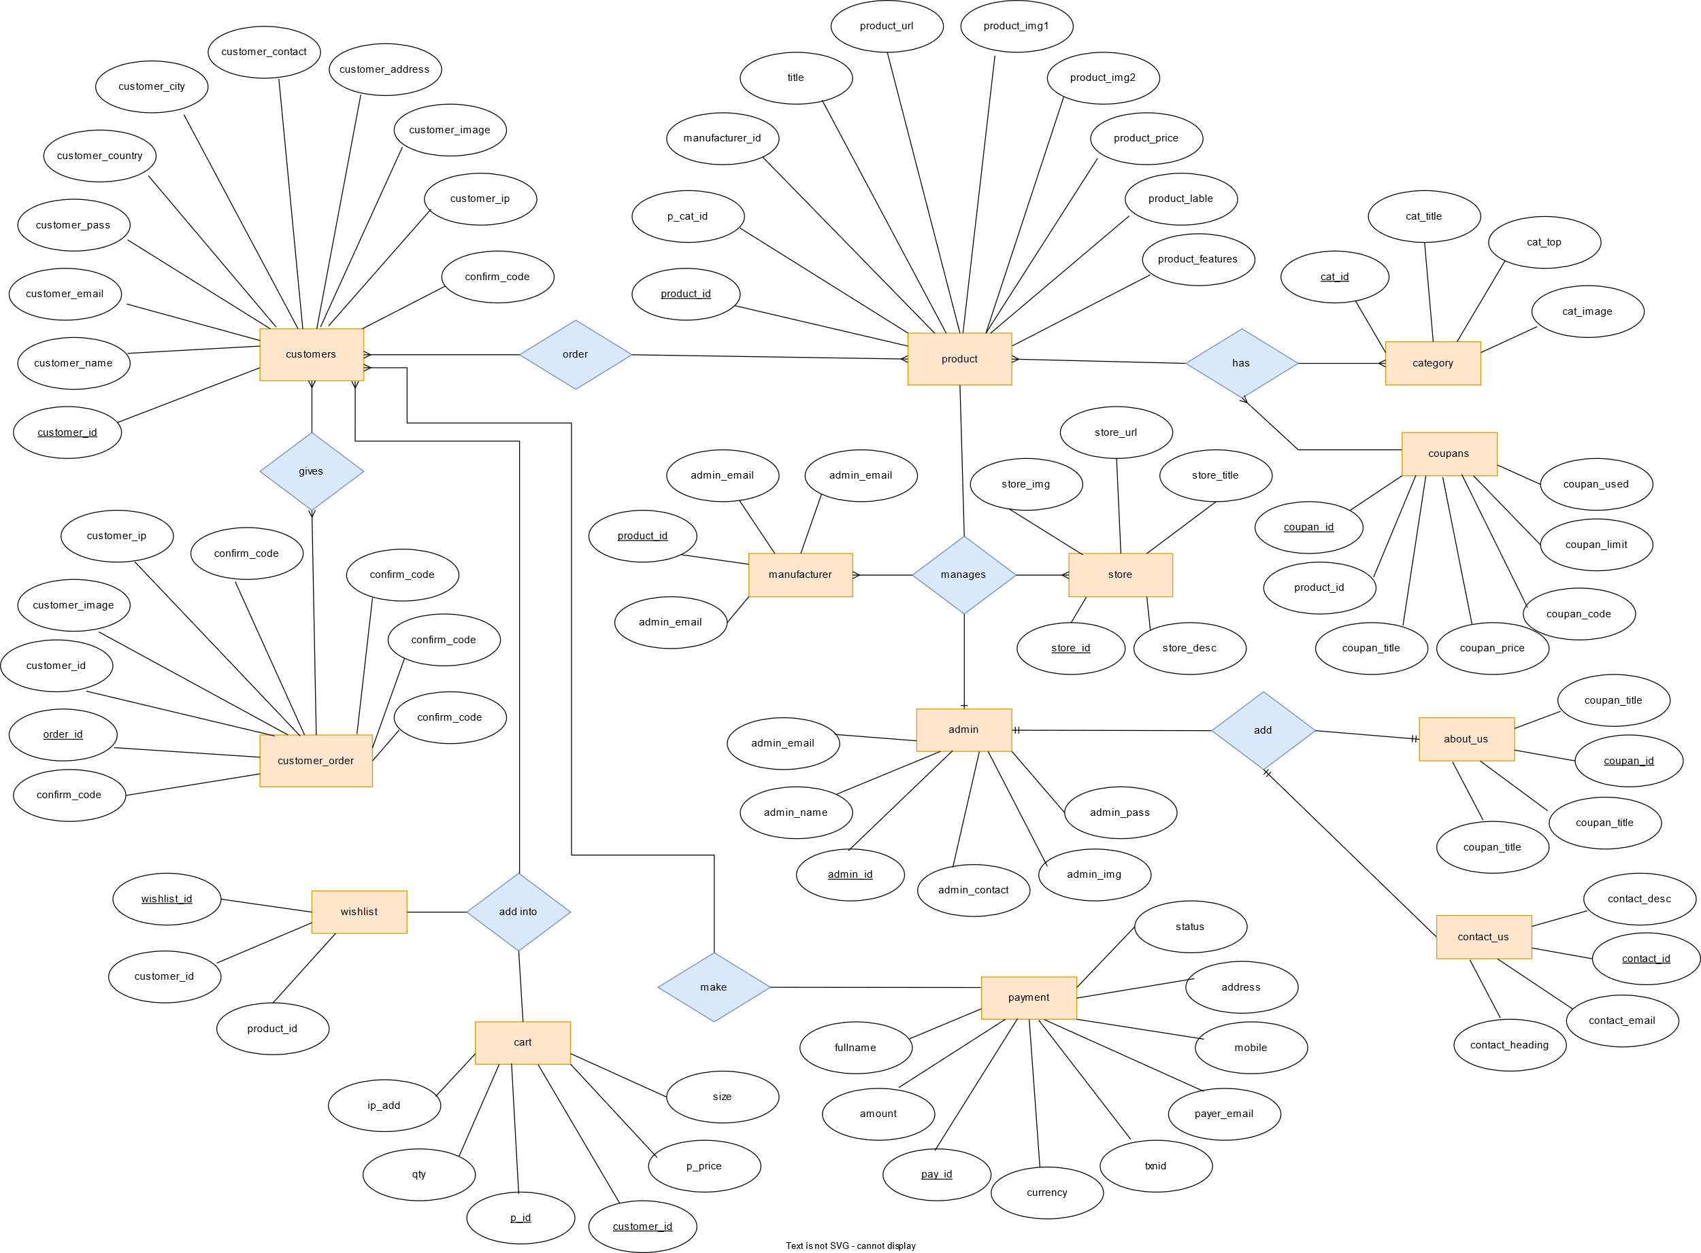

**6. 4. User Interface Design (Screen Layout)**

**Home page**

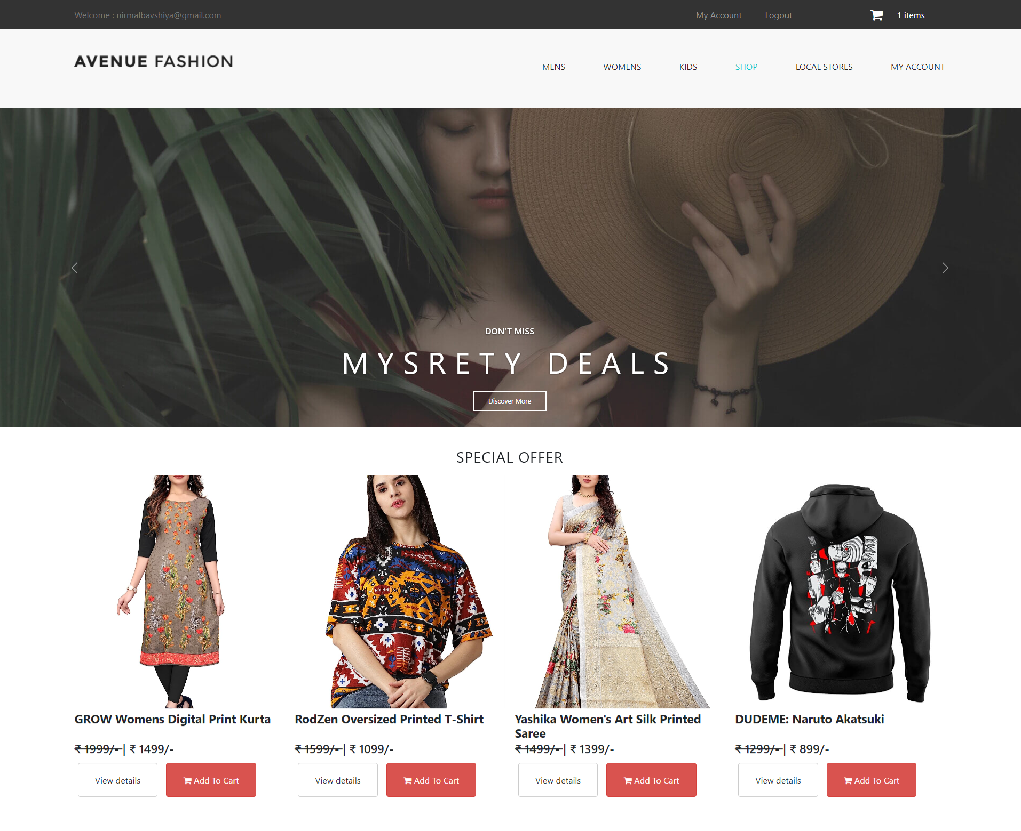

**Login page**

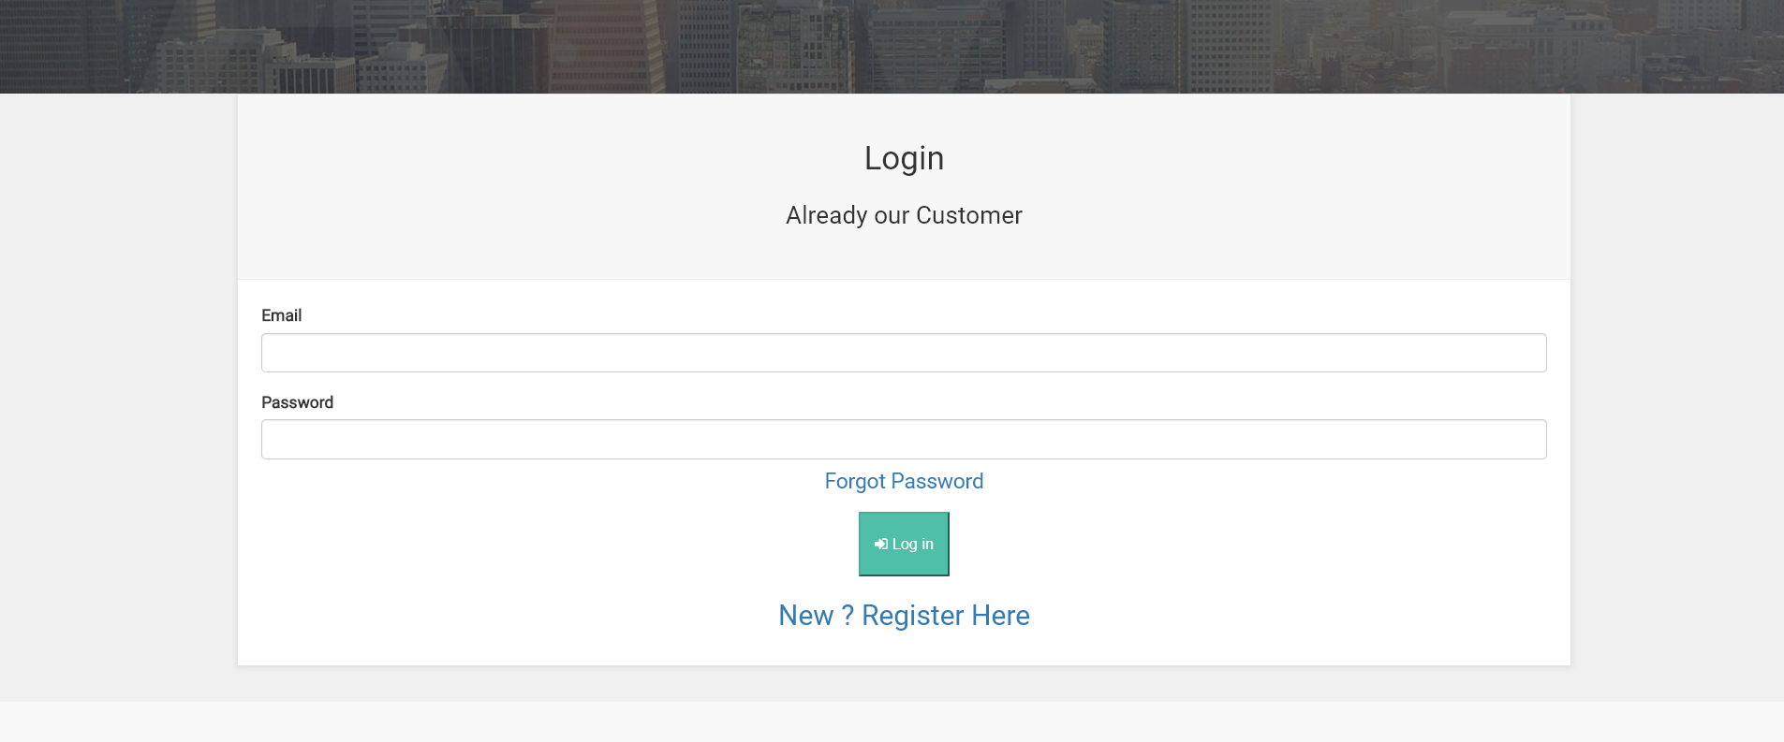

**Register page**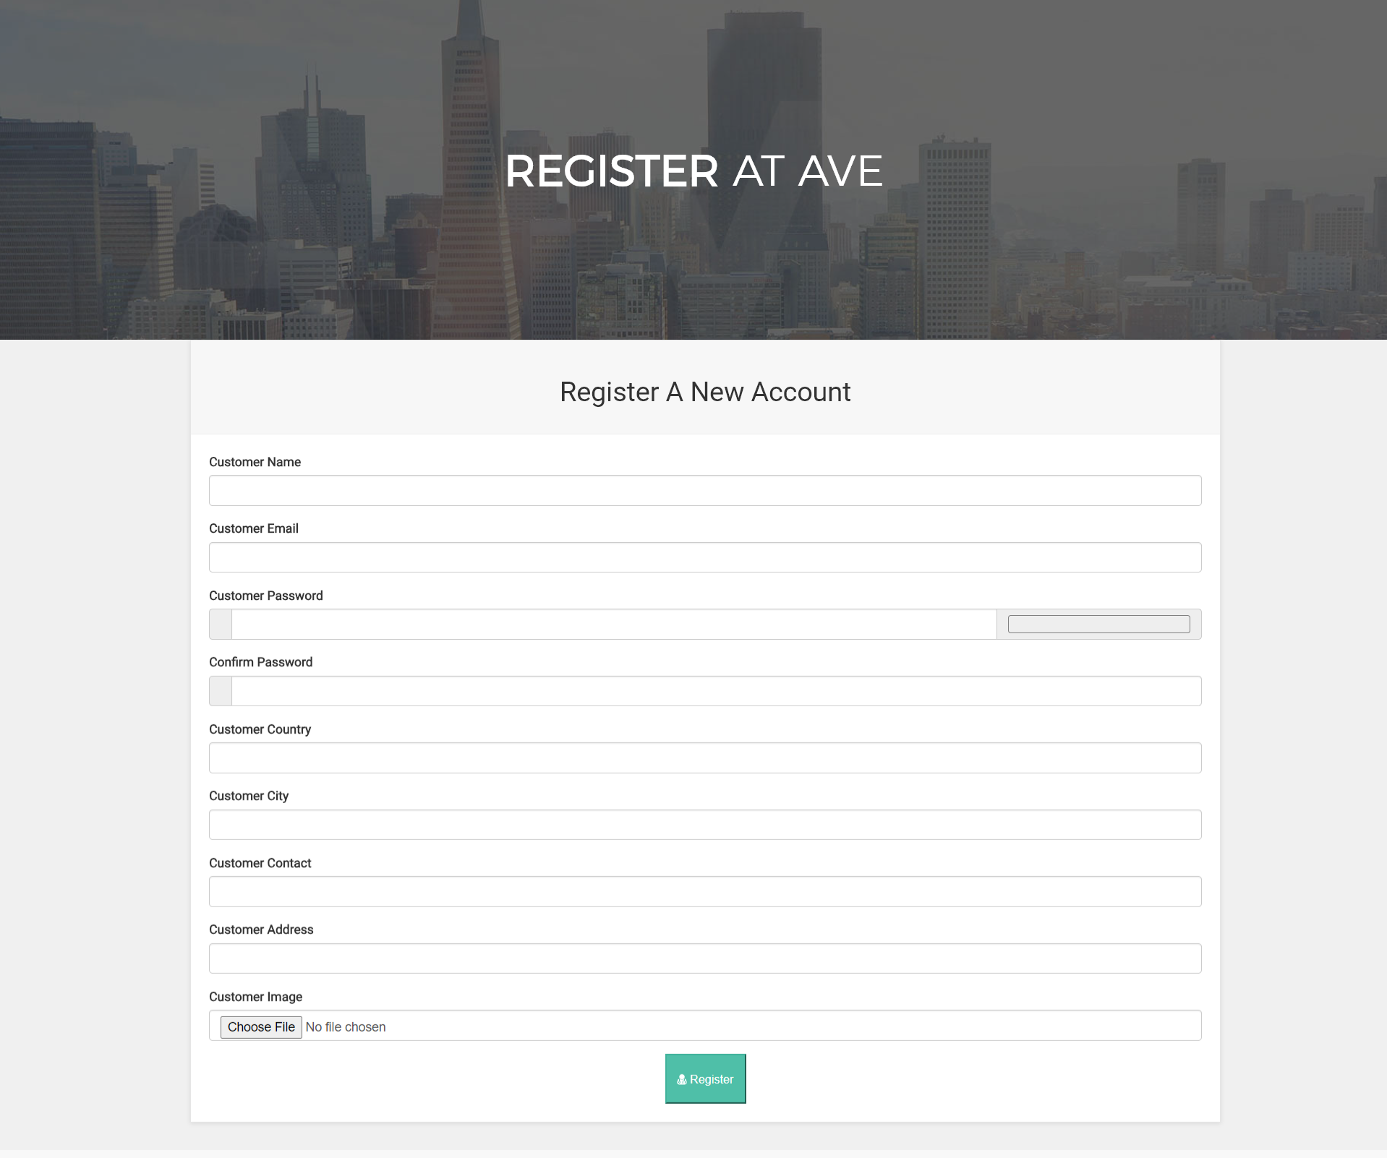

**Account activation email**

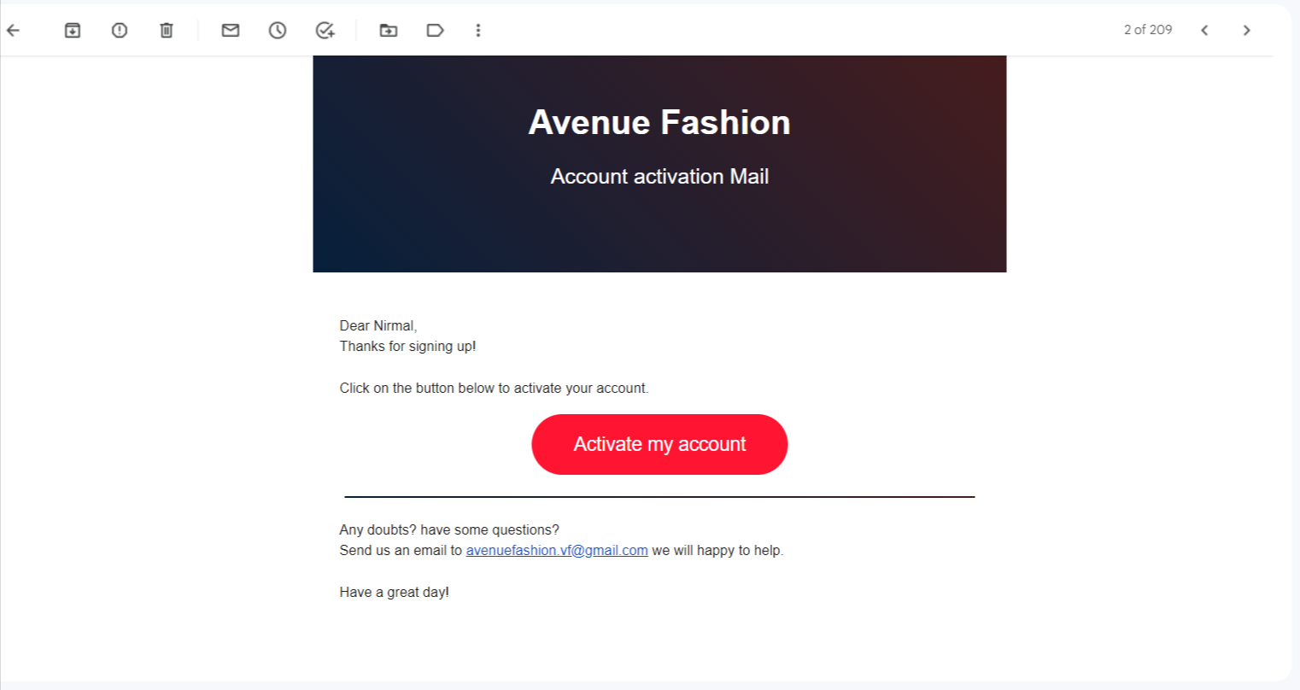

**\*Client side\***

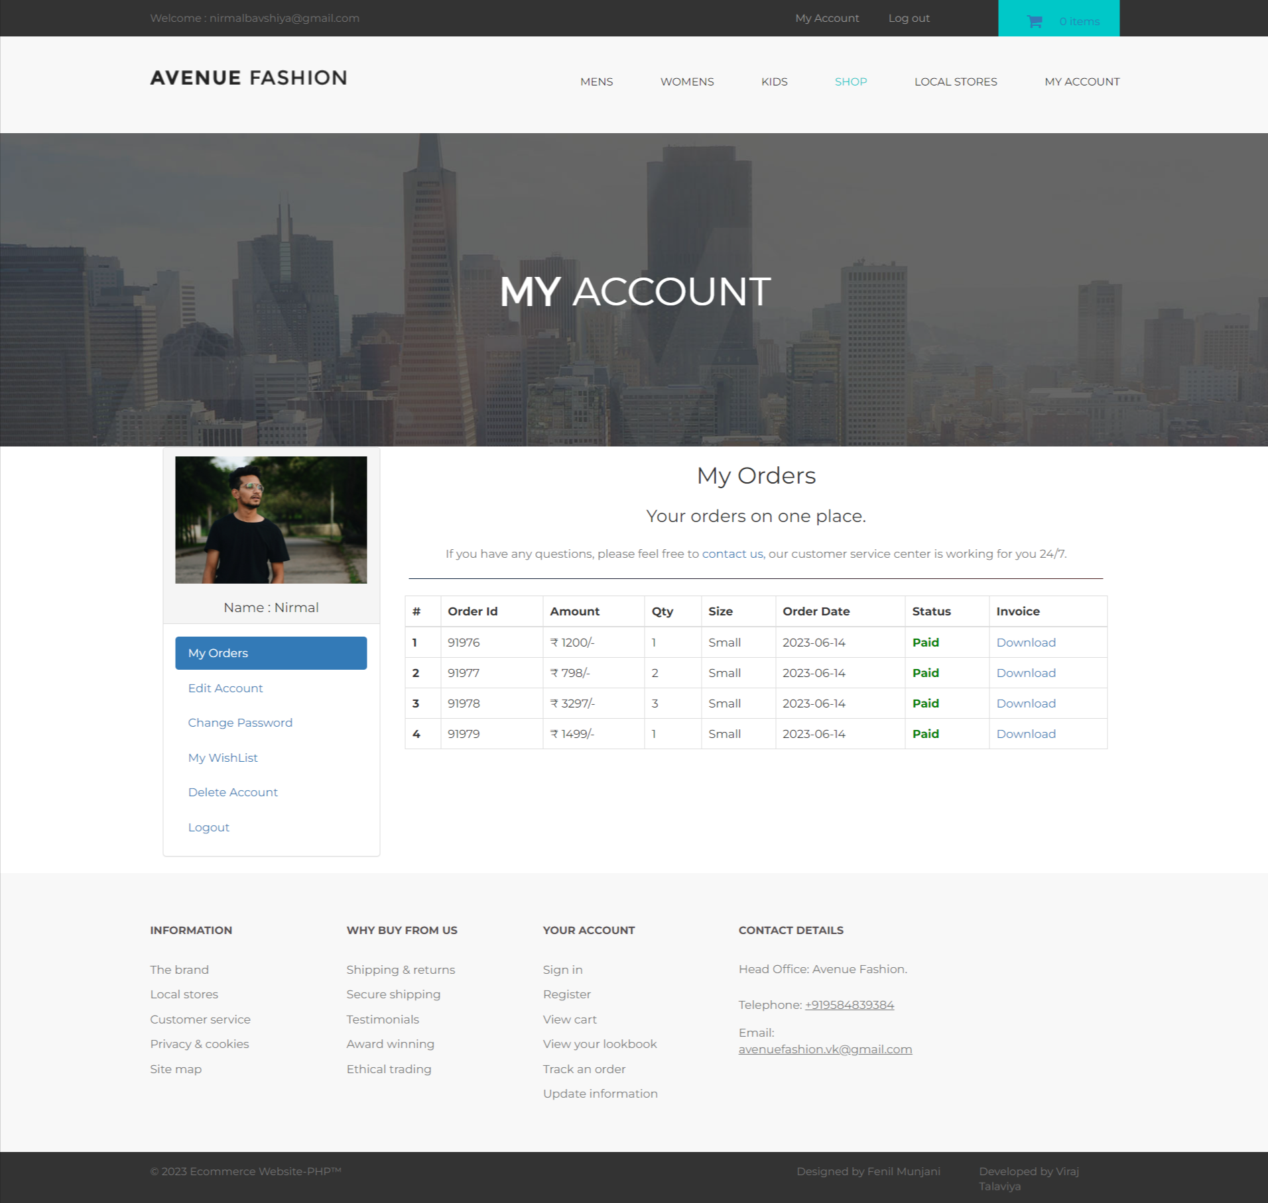**My Account page**

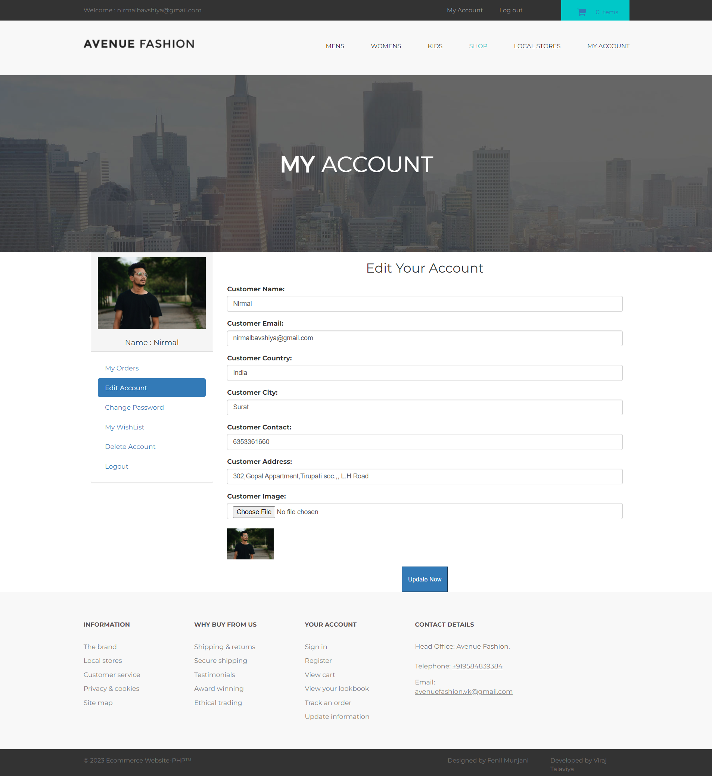**Edit Account**

**Change password**

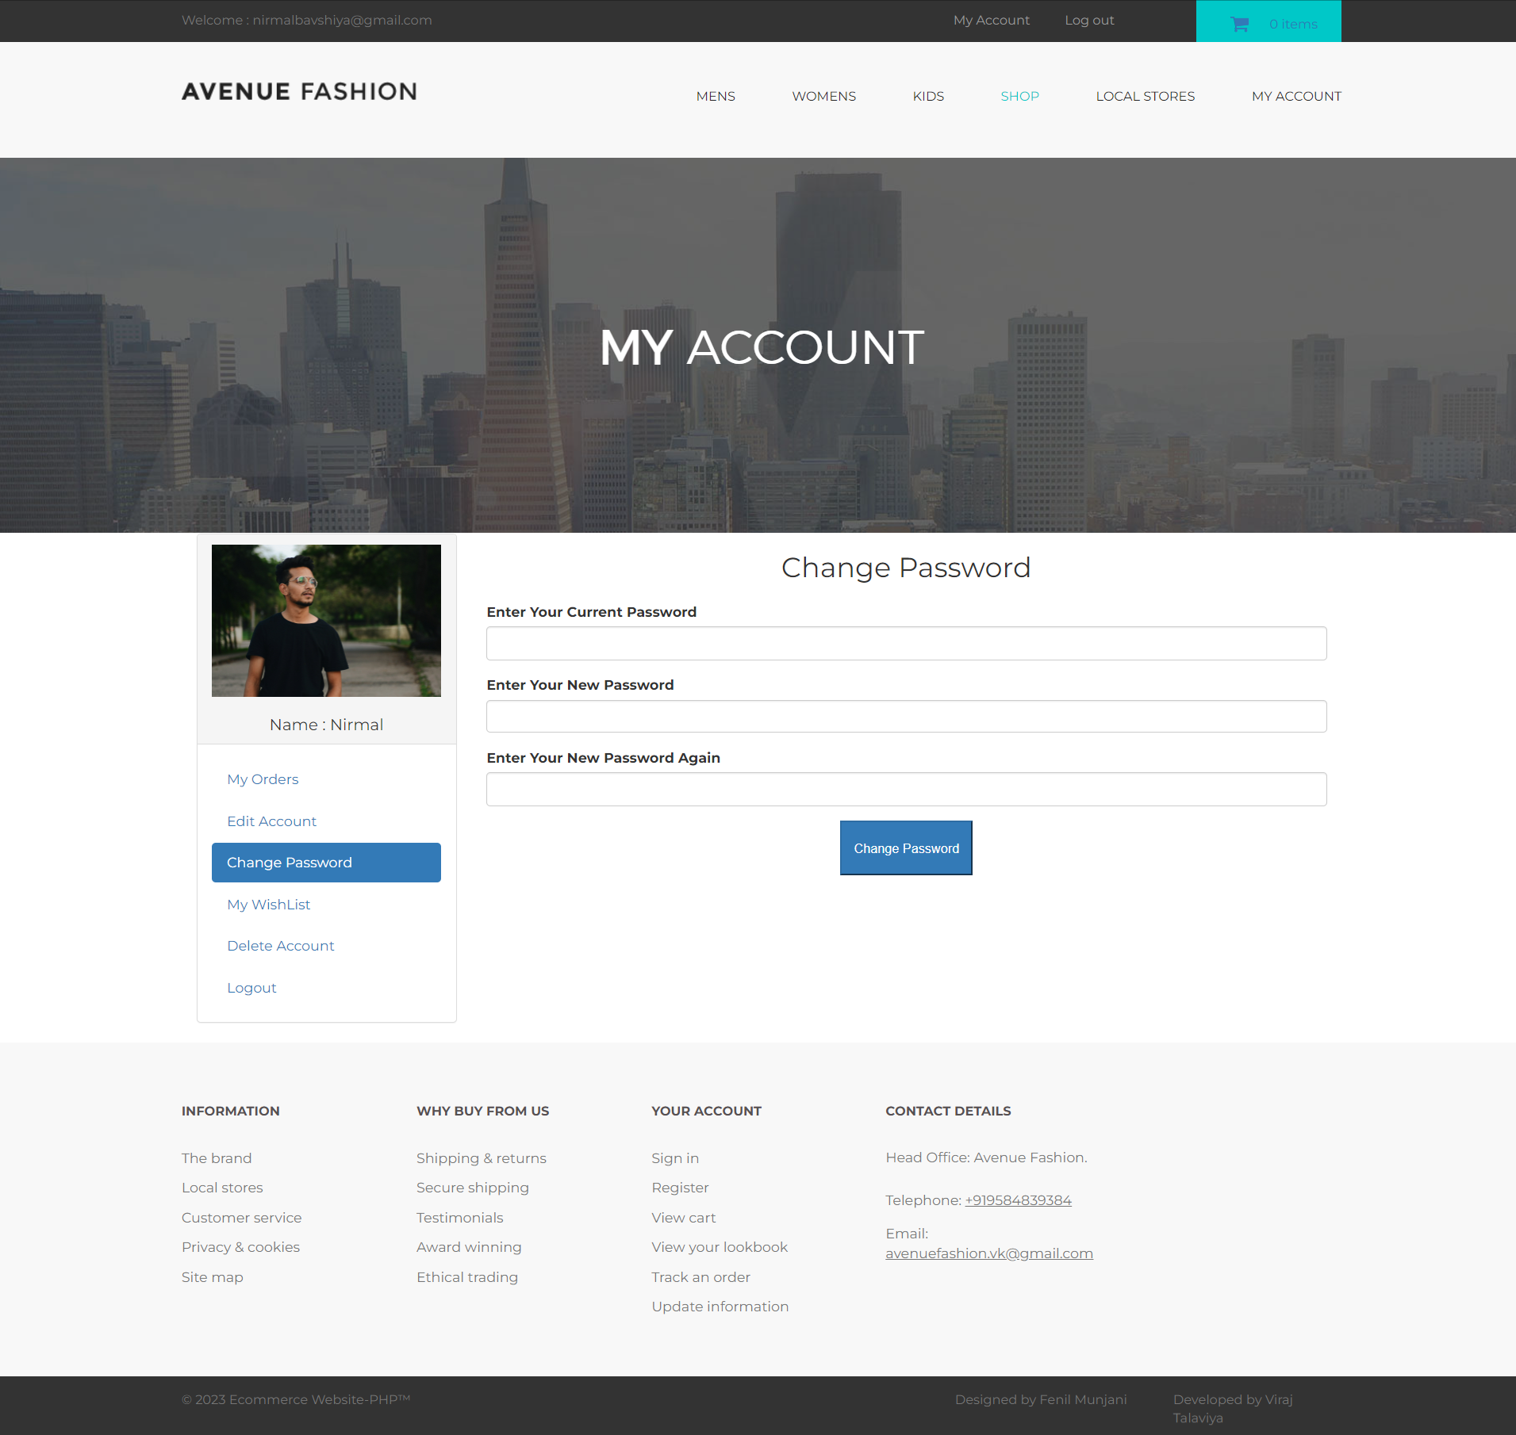

**My wishlist**

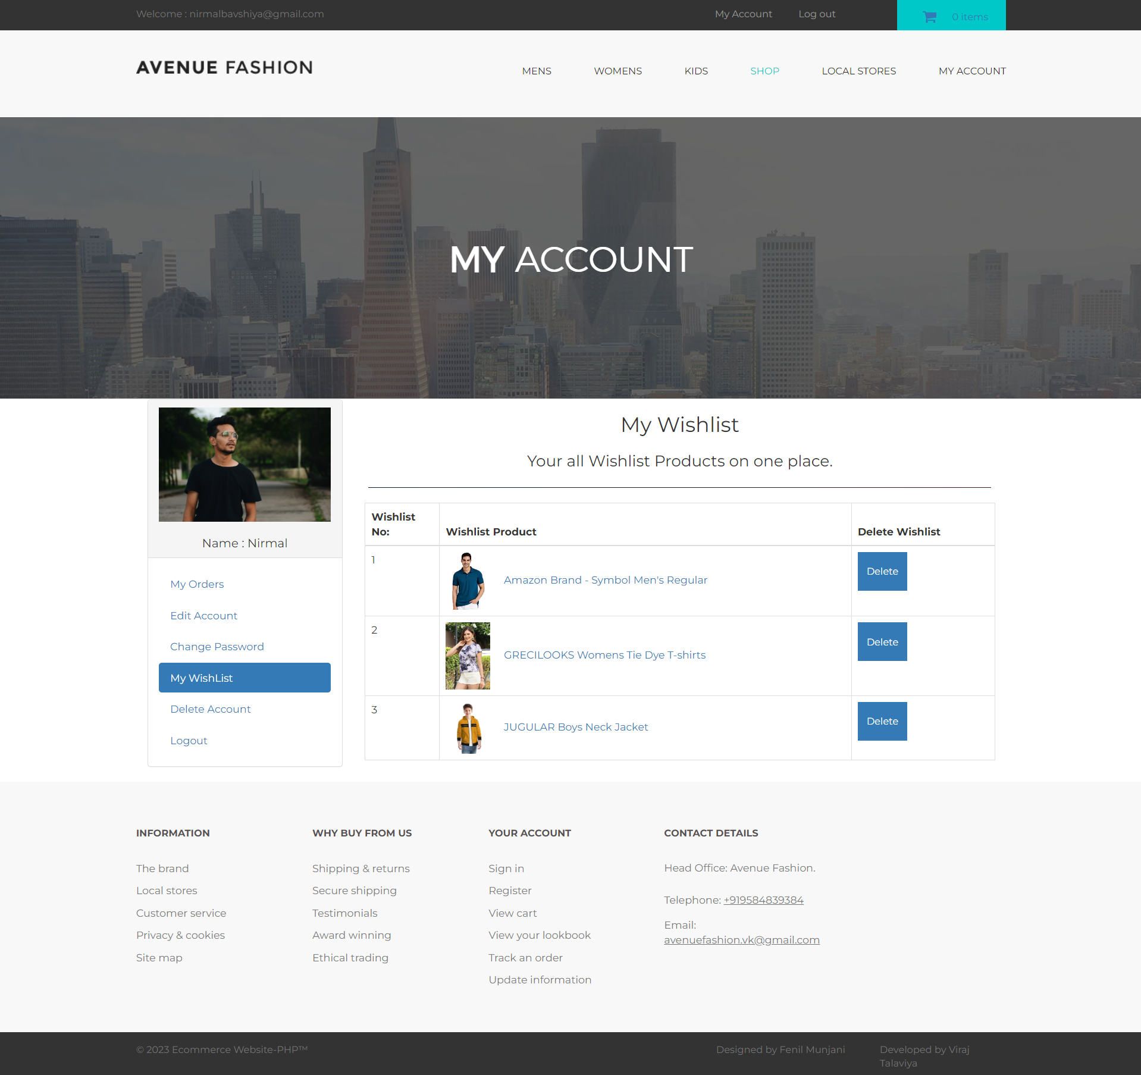

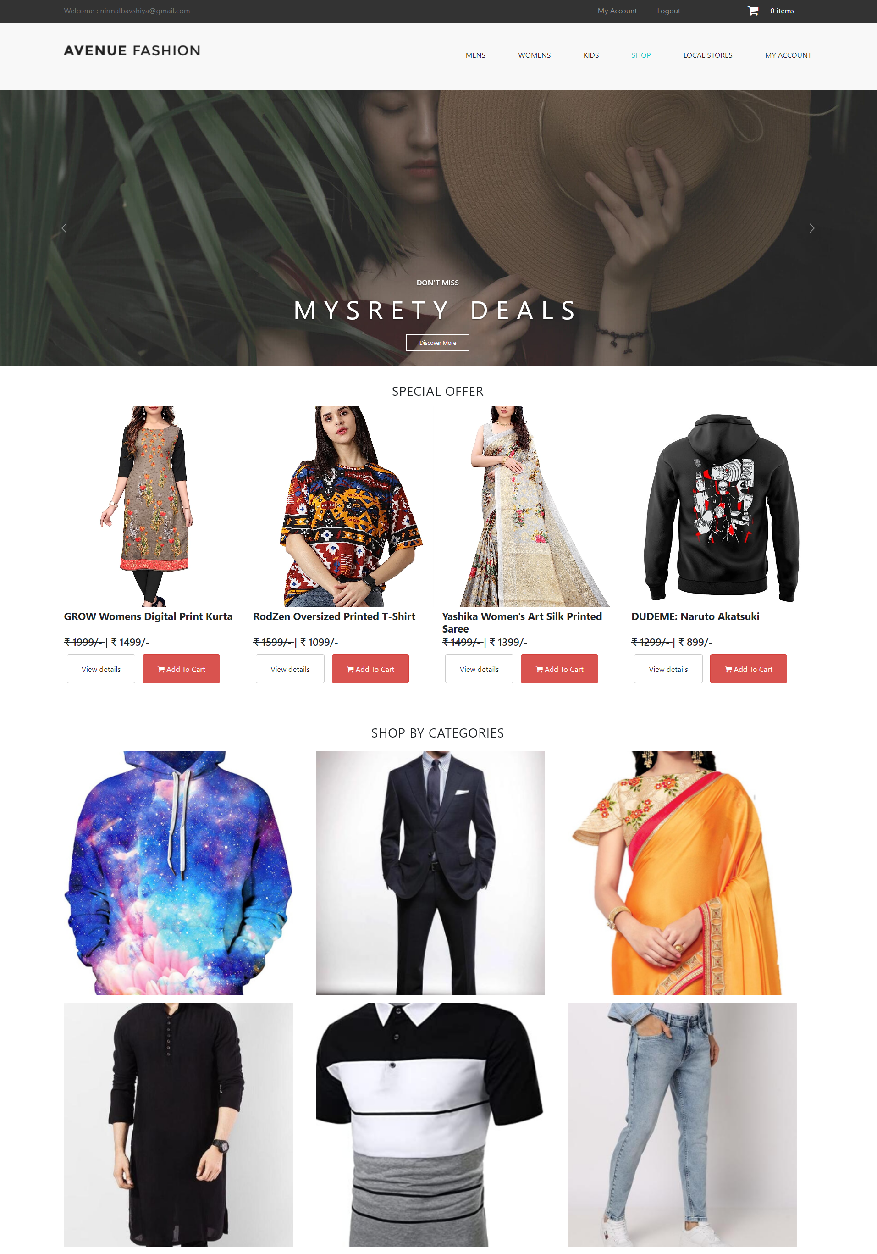

**Men’s wear**

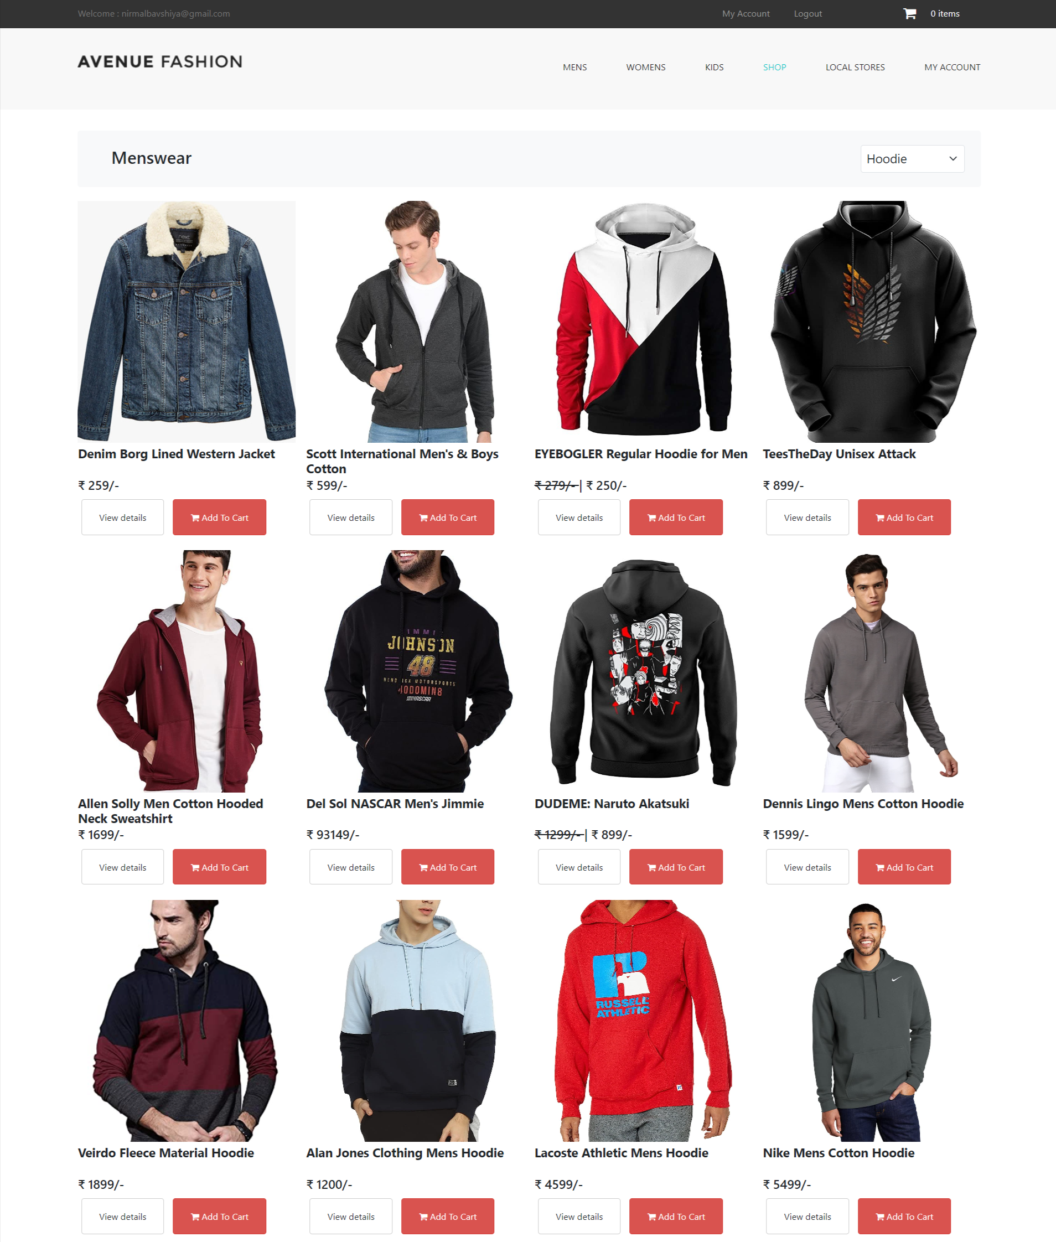

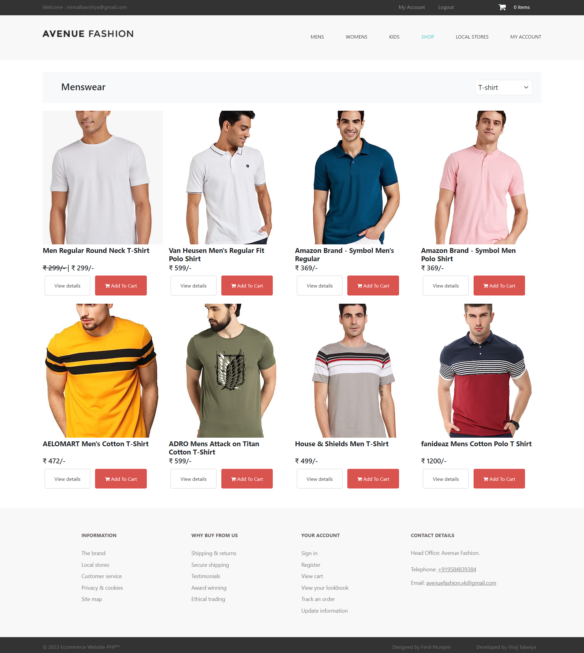

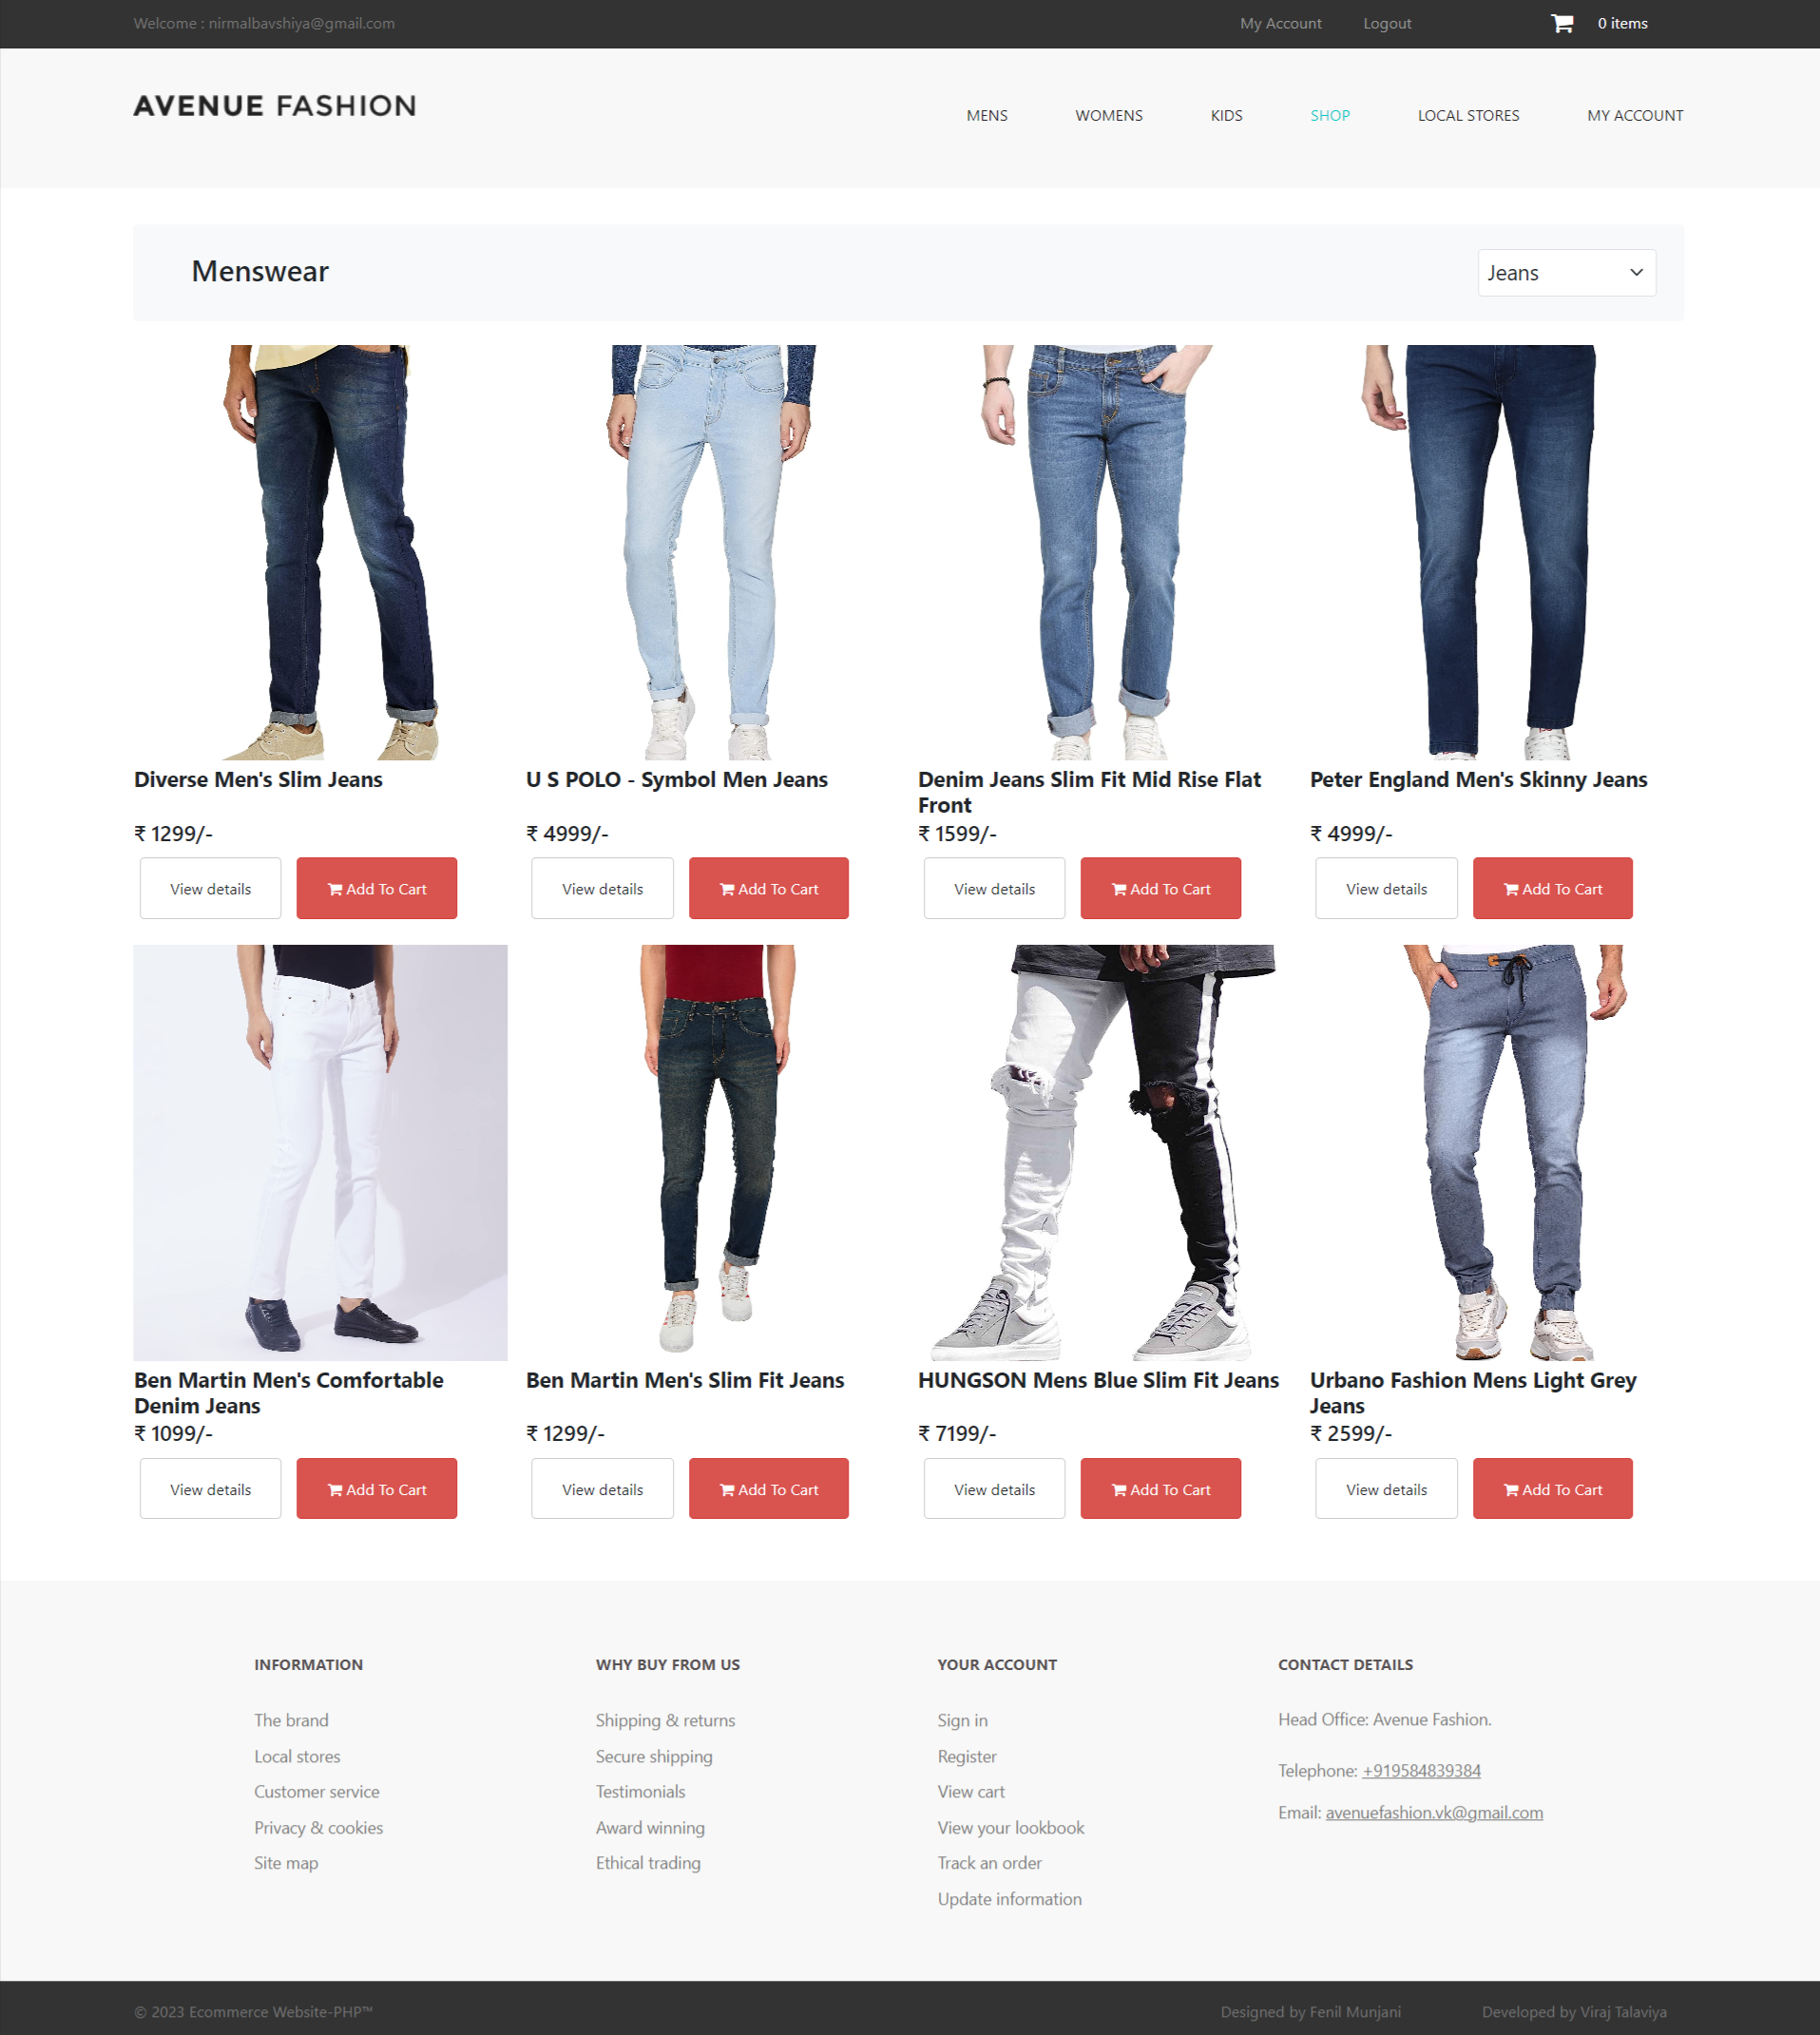

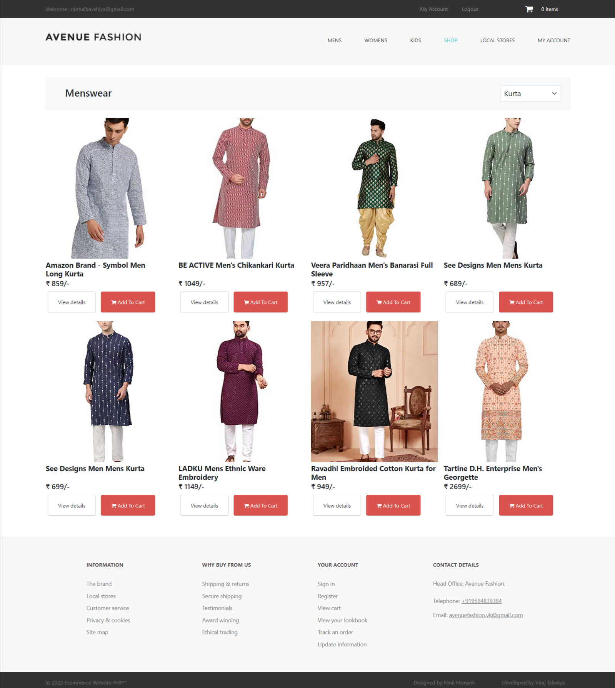

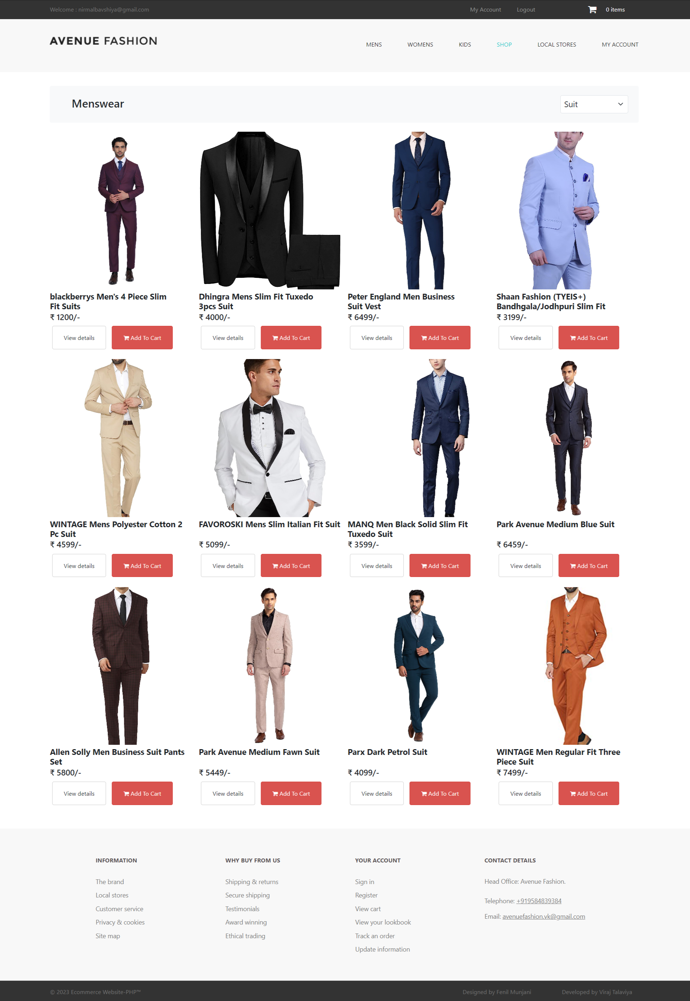

**Women’s wear**

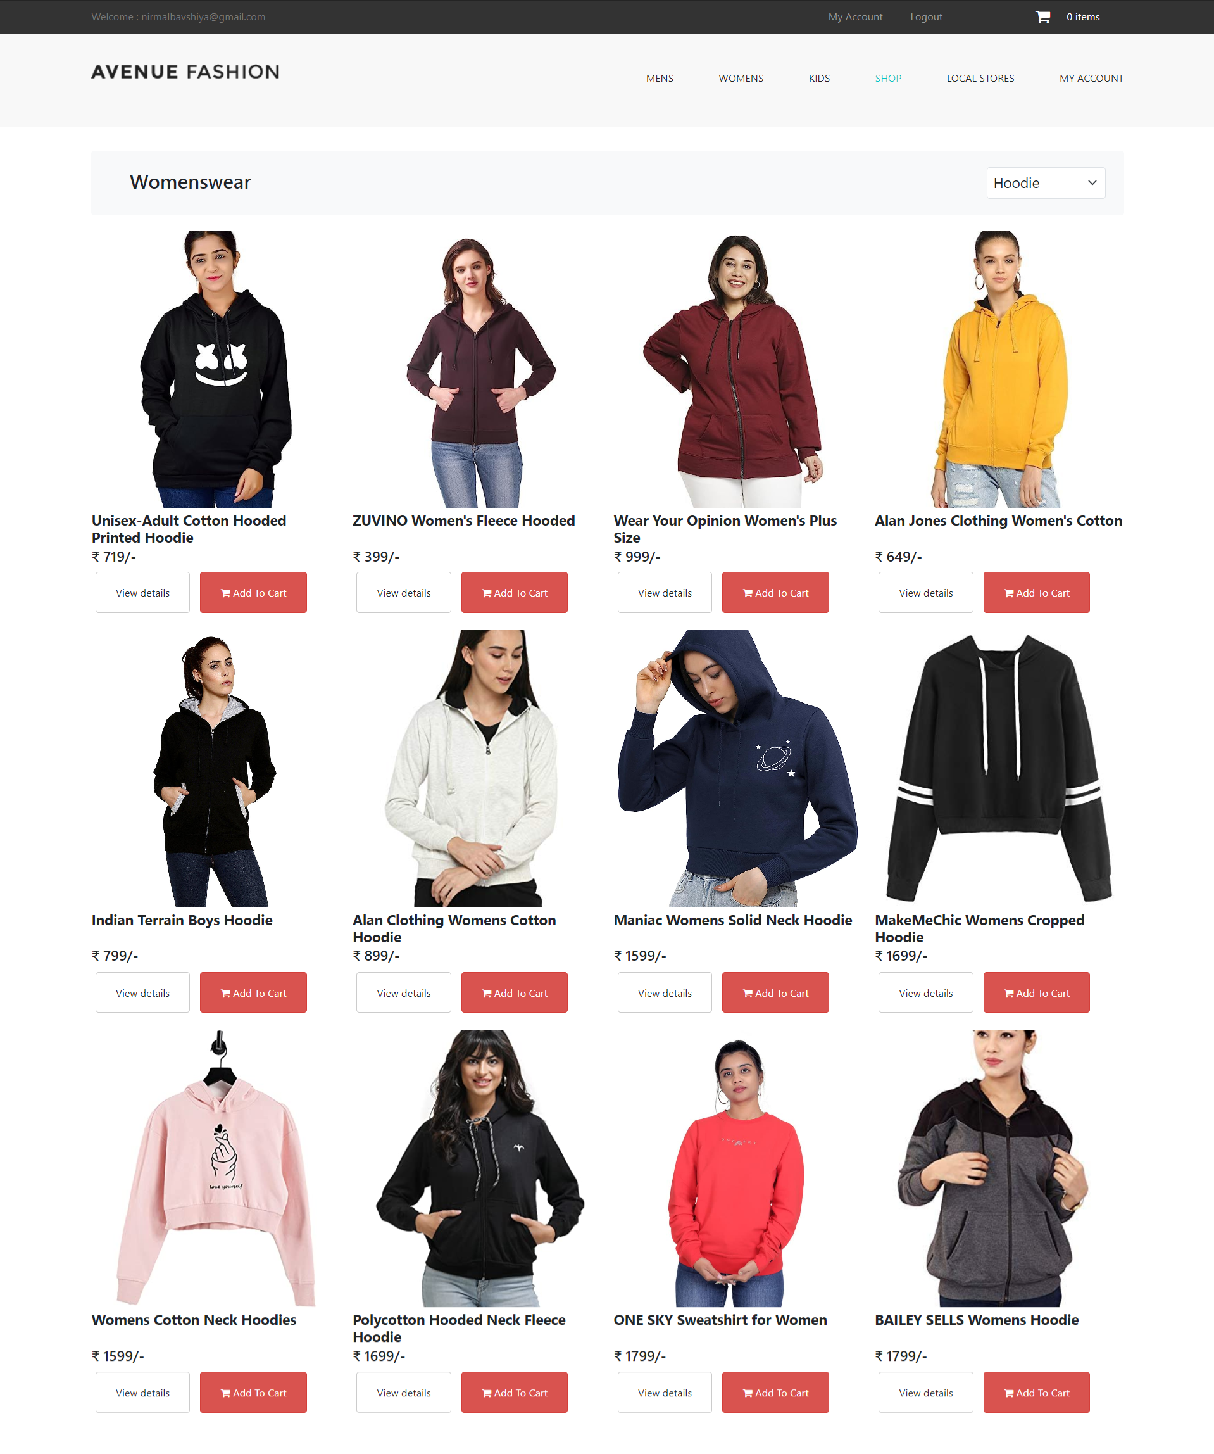

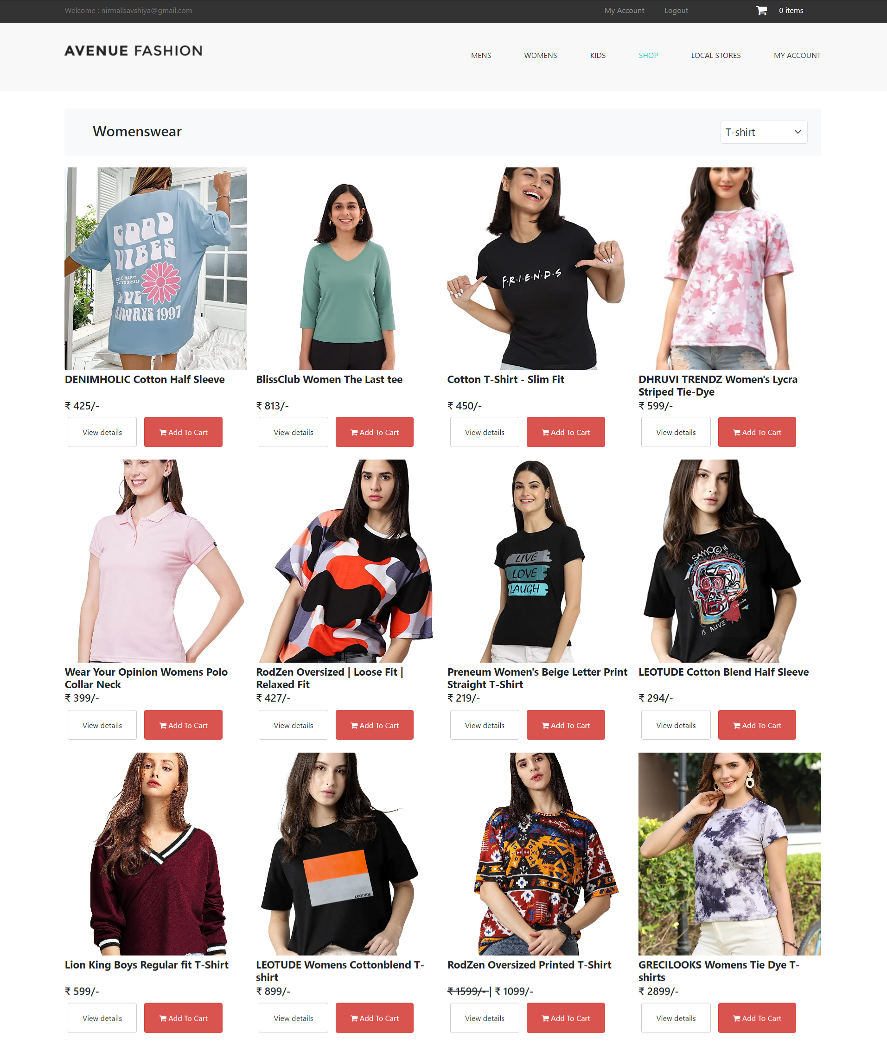

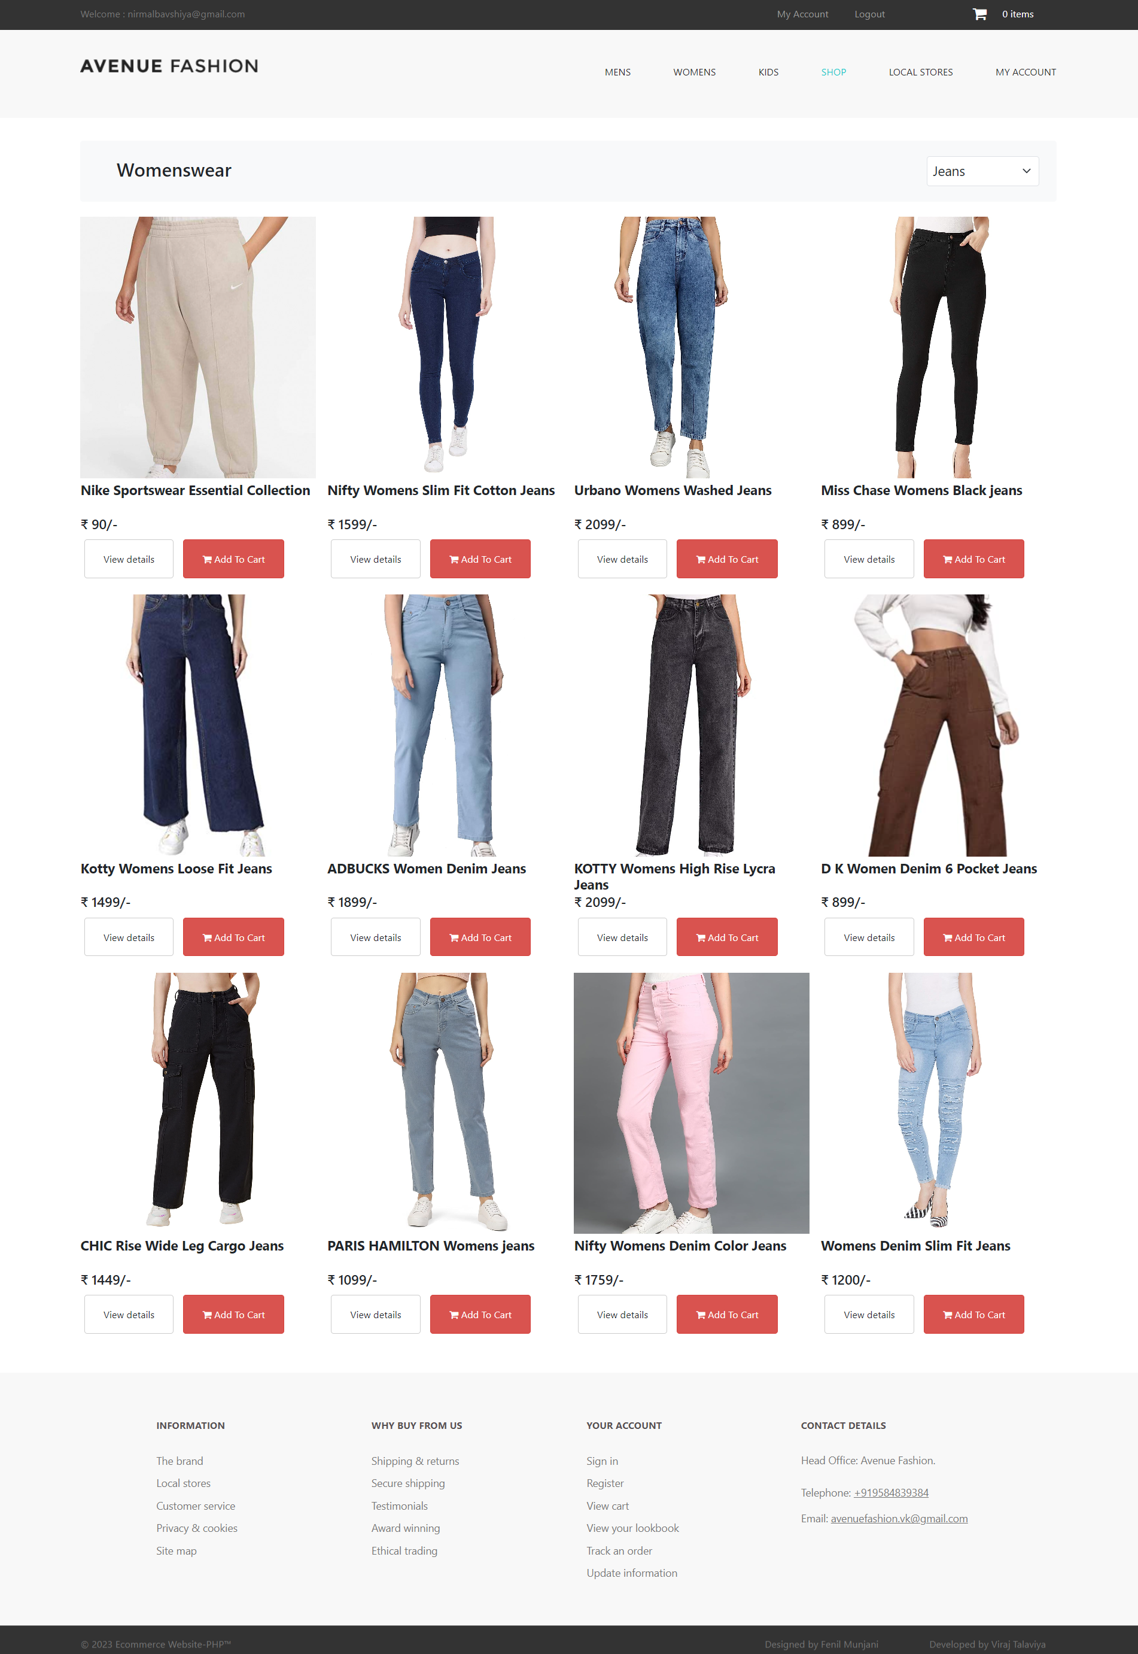

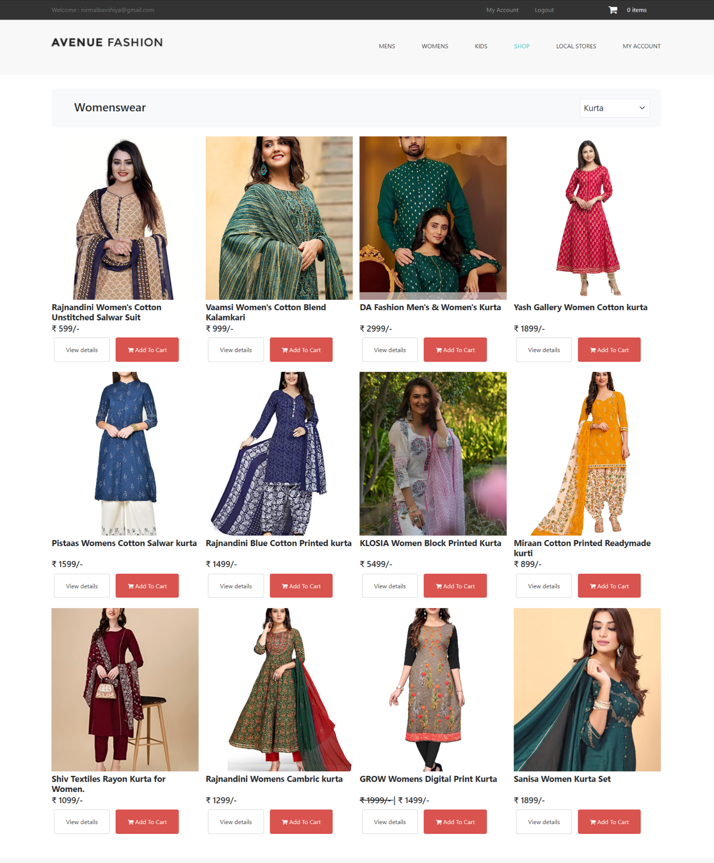

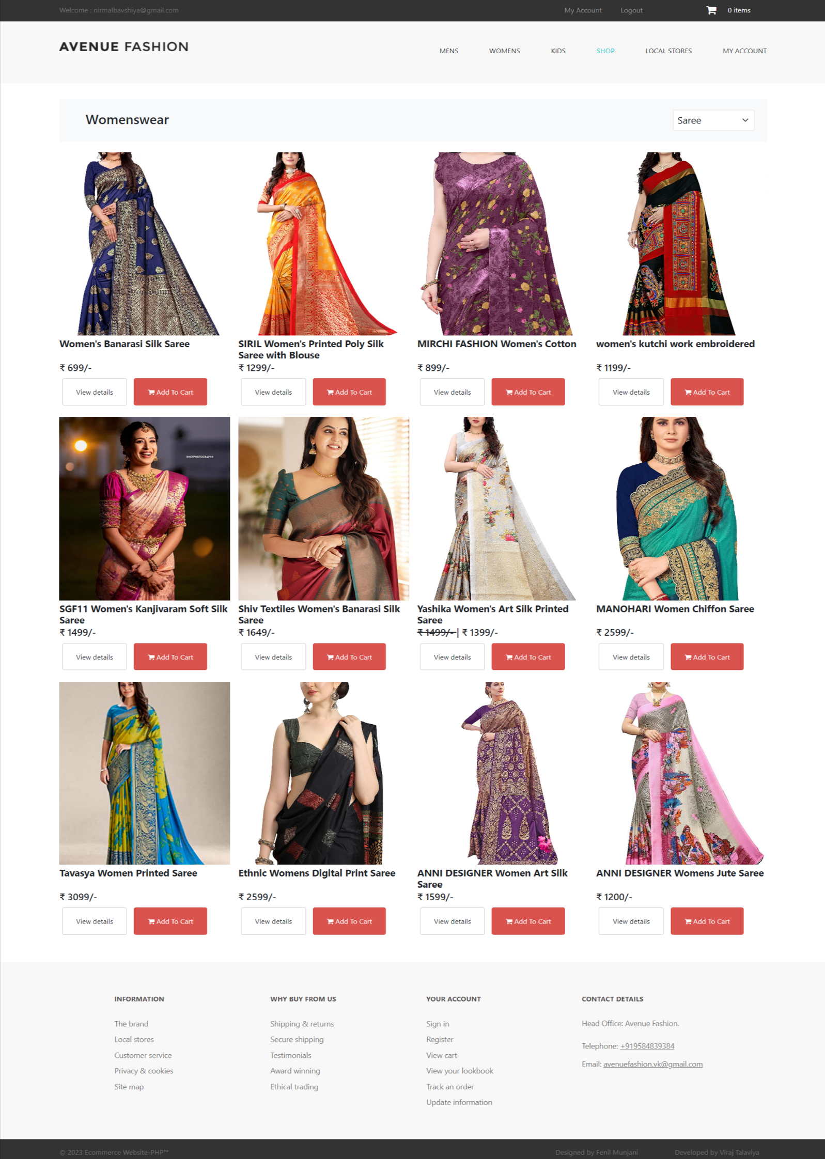

**Kid’s wear**

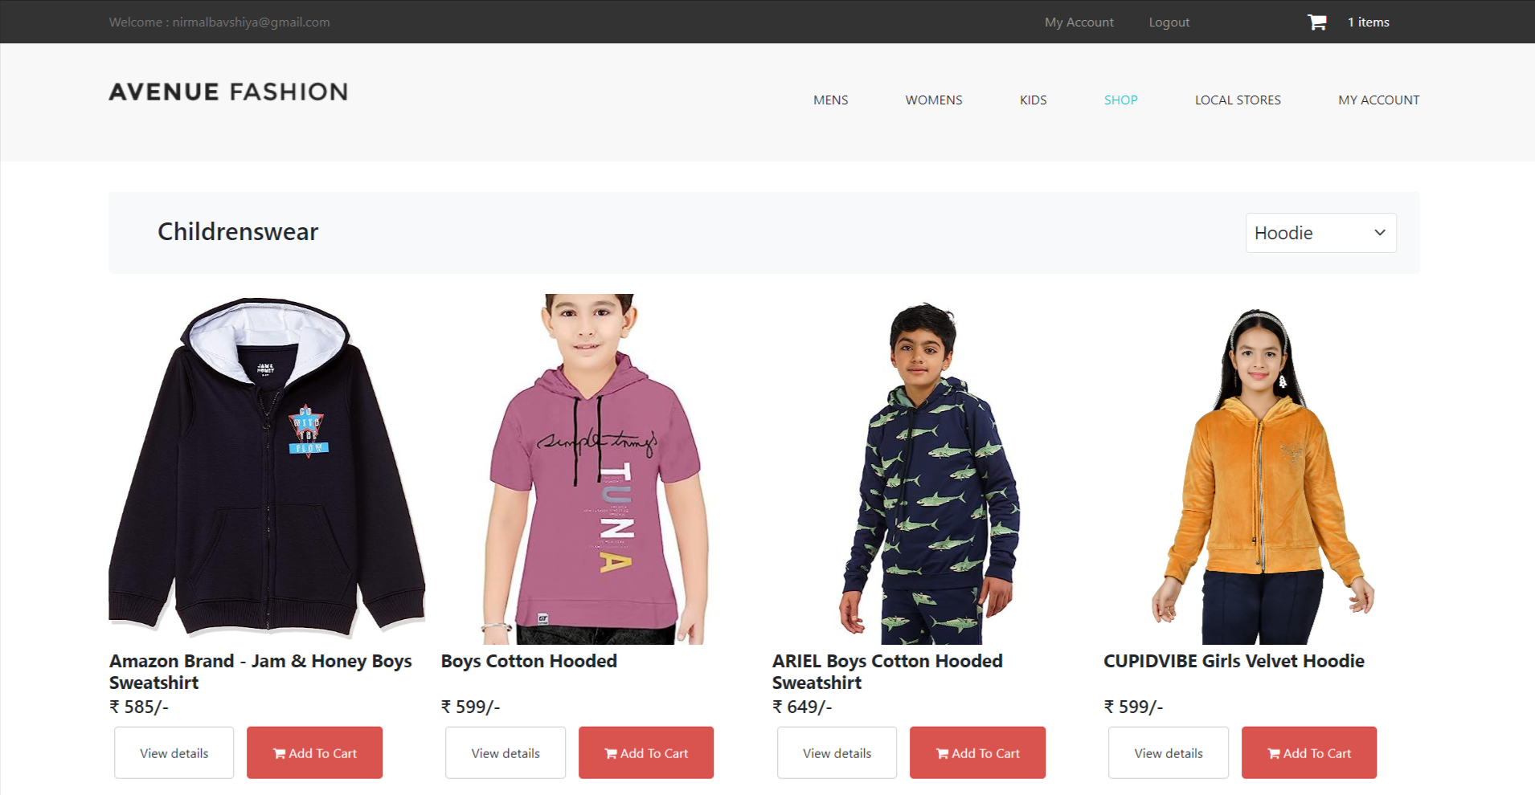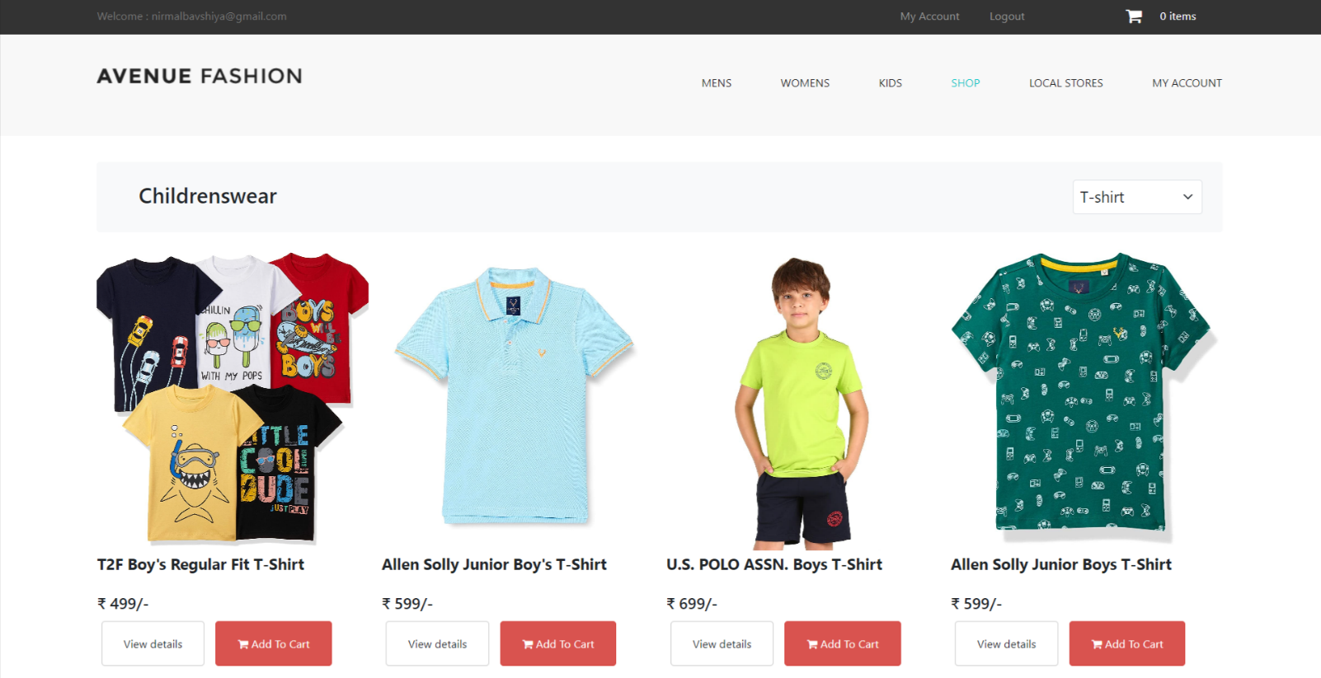

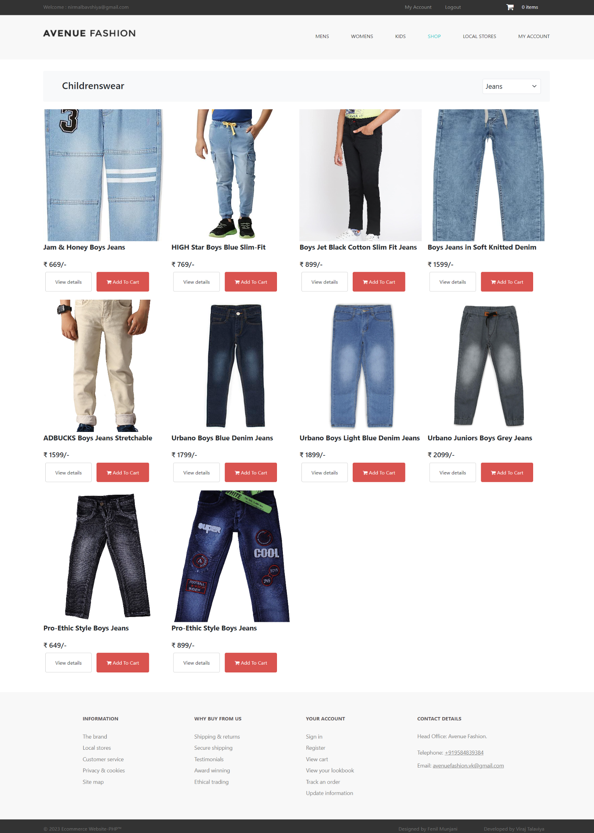

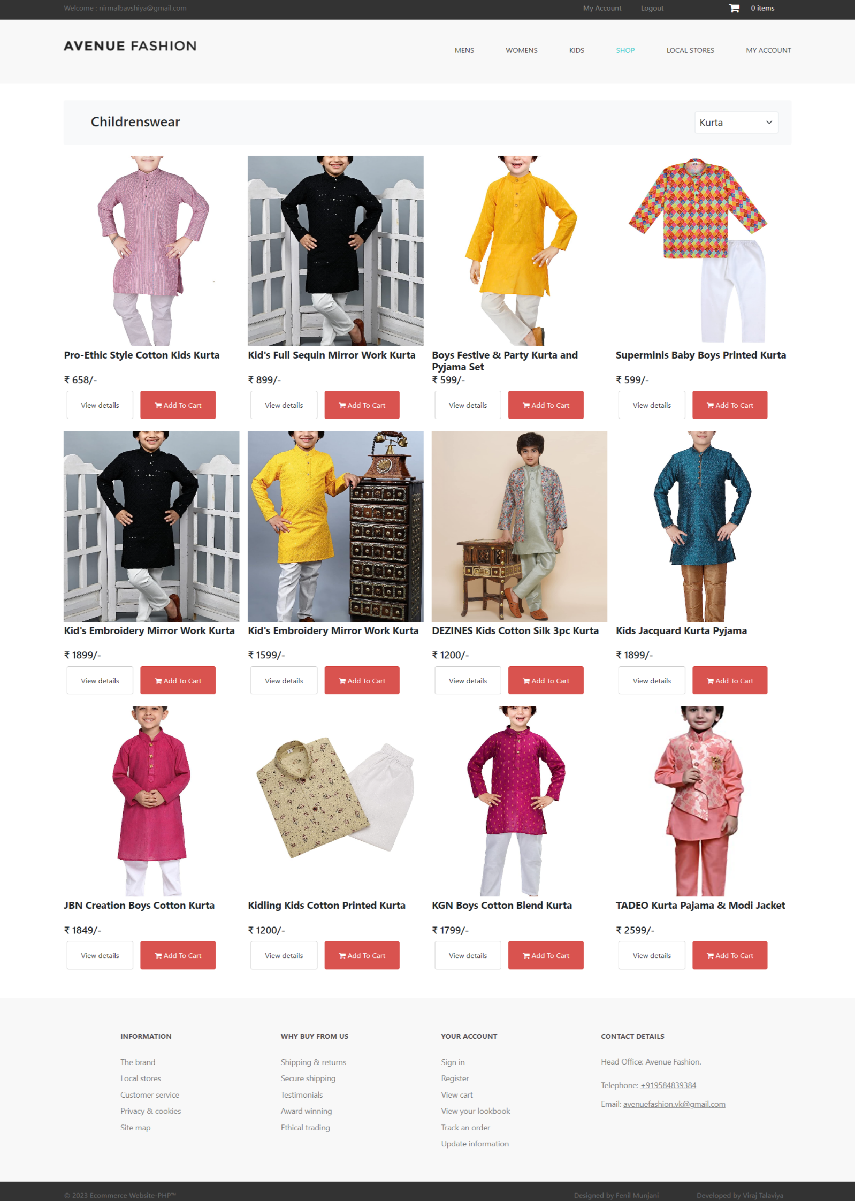

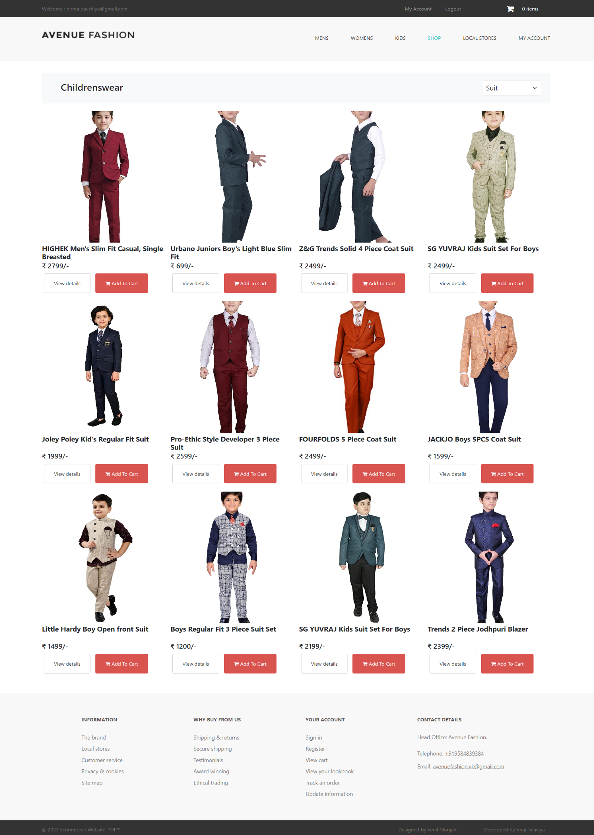

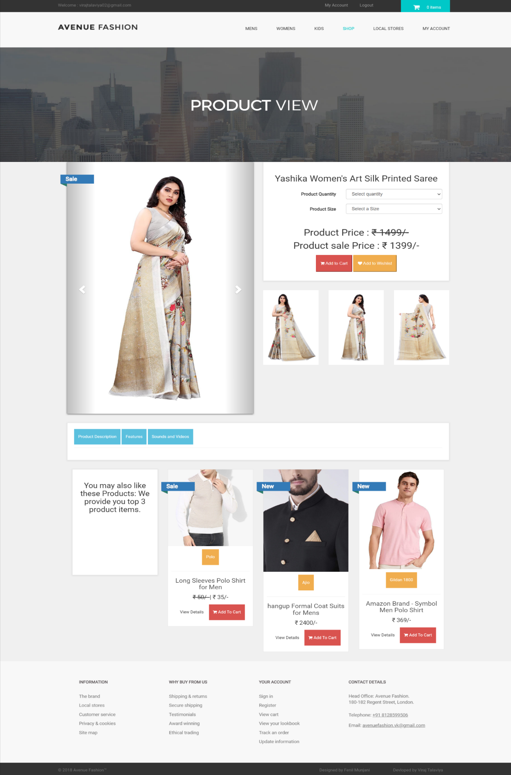

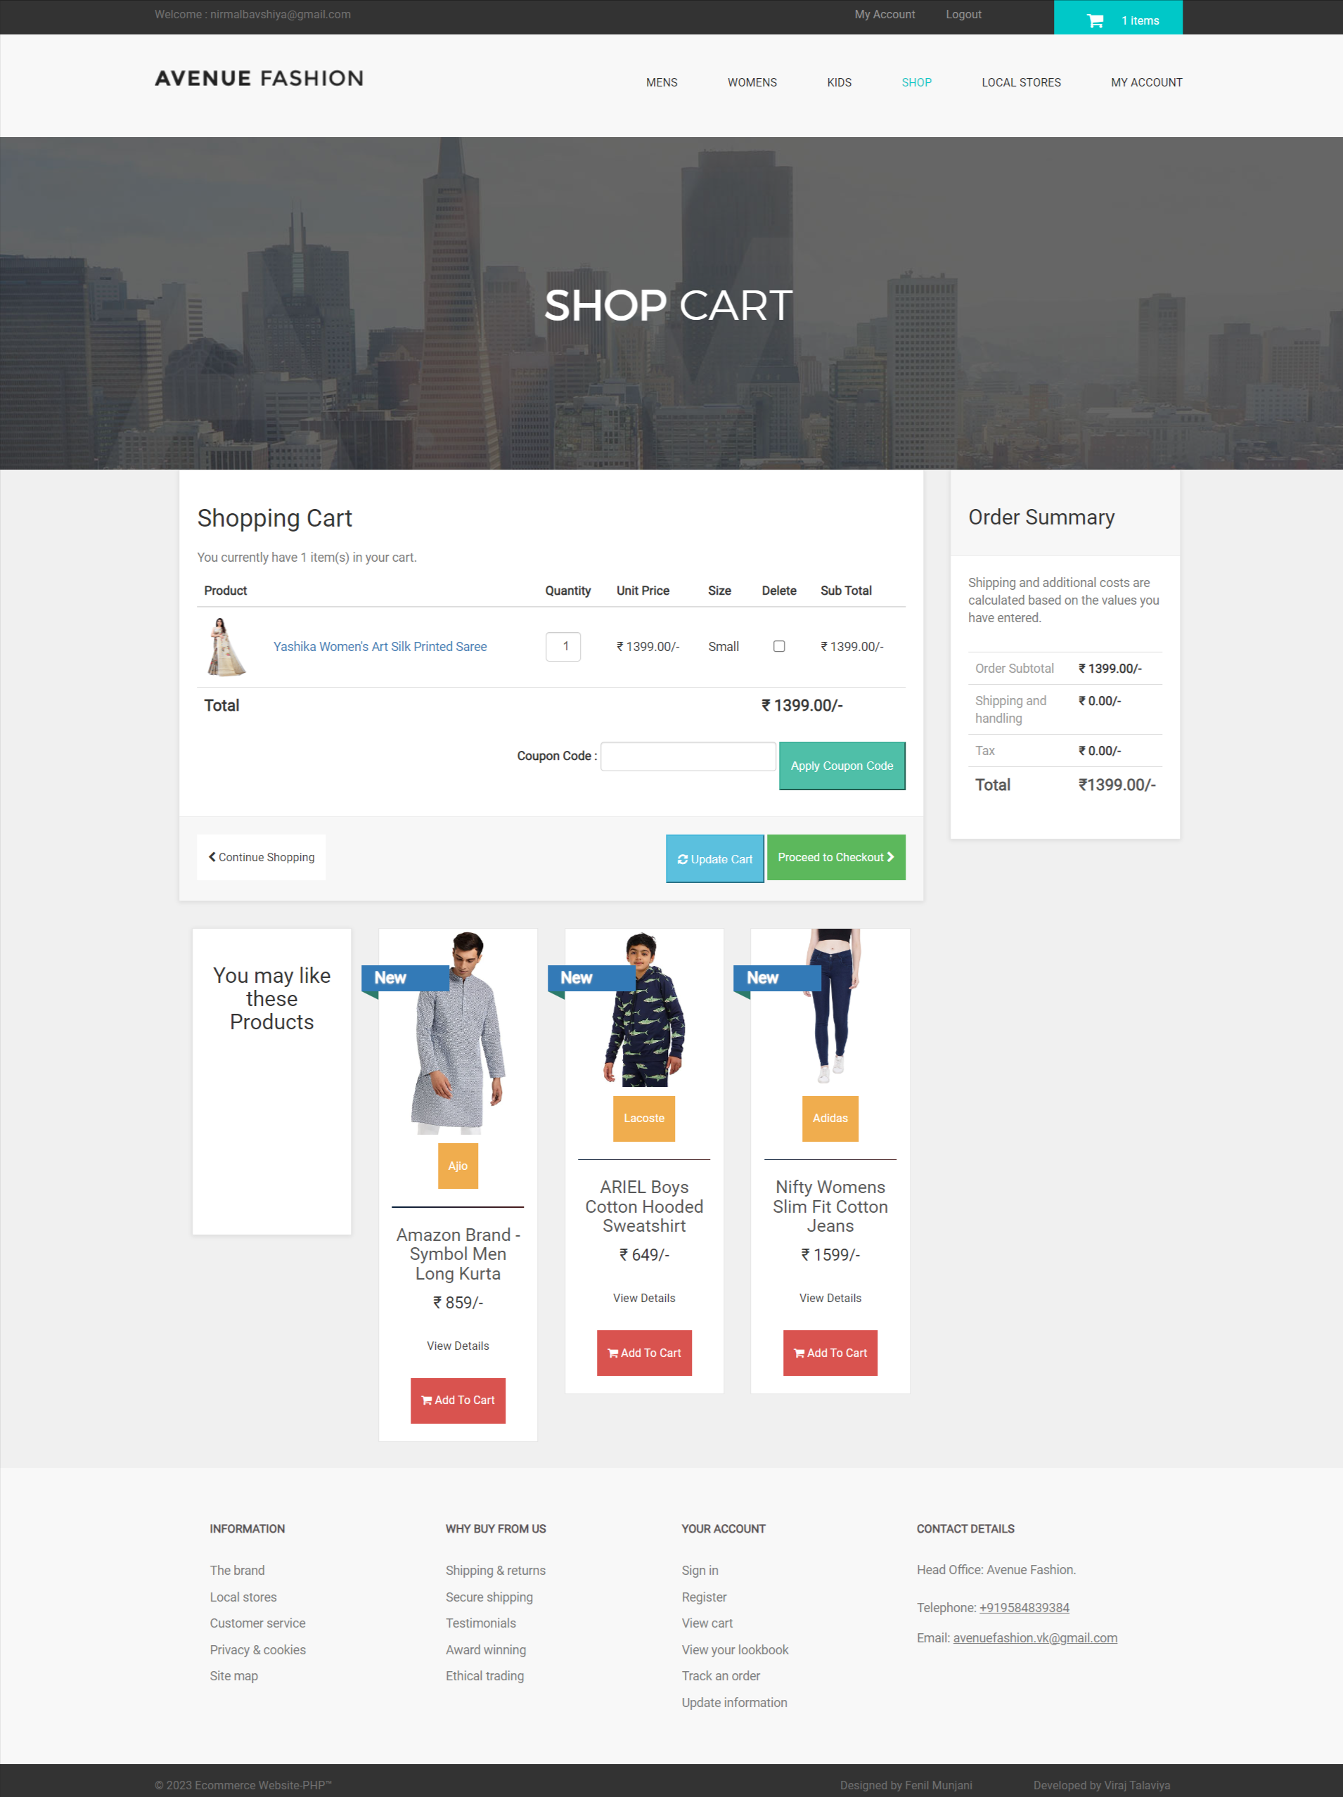

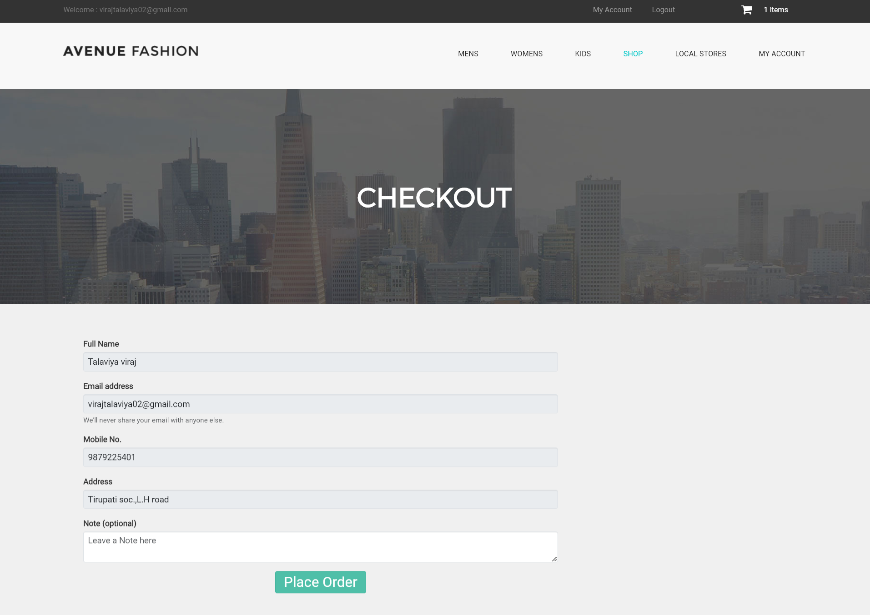

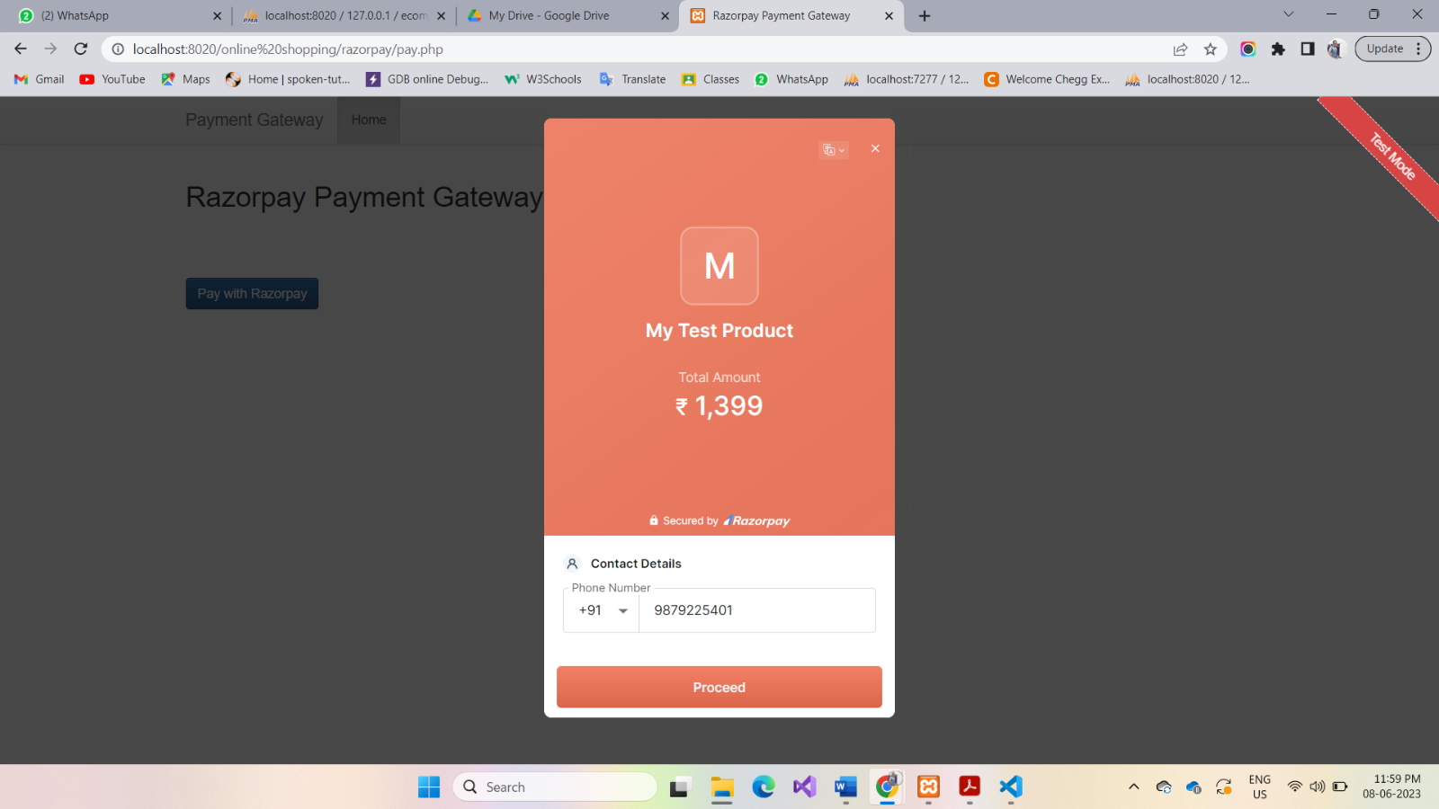

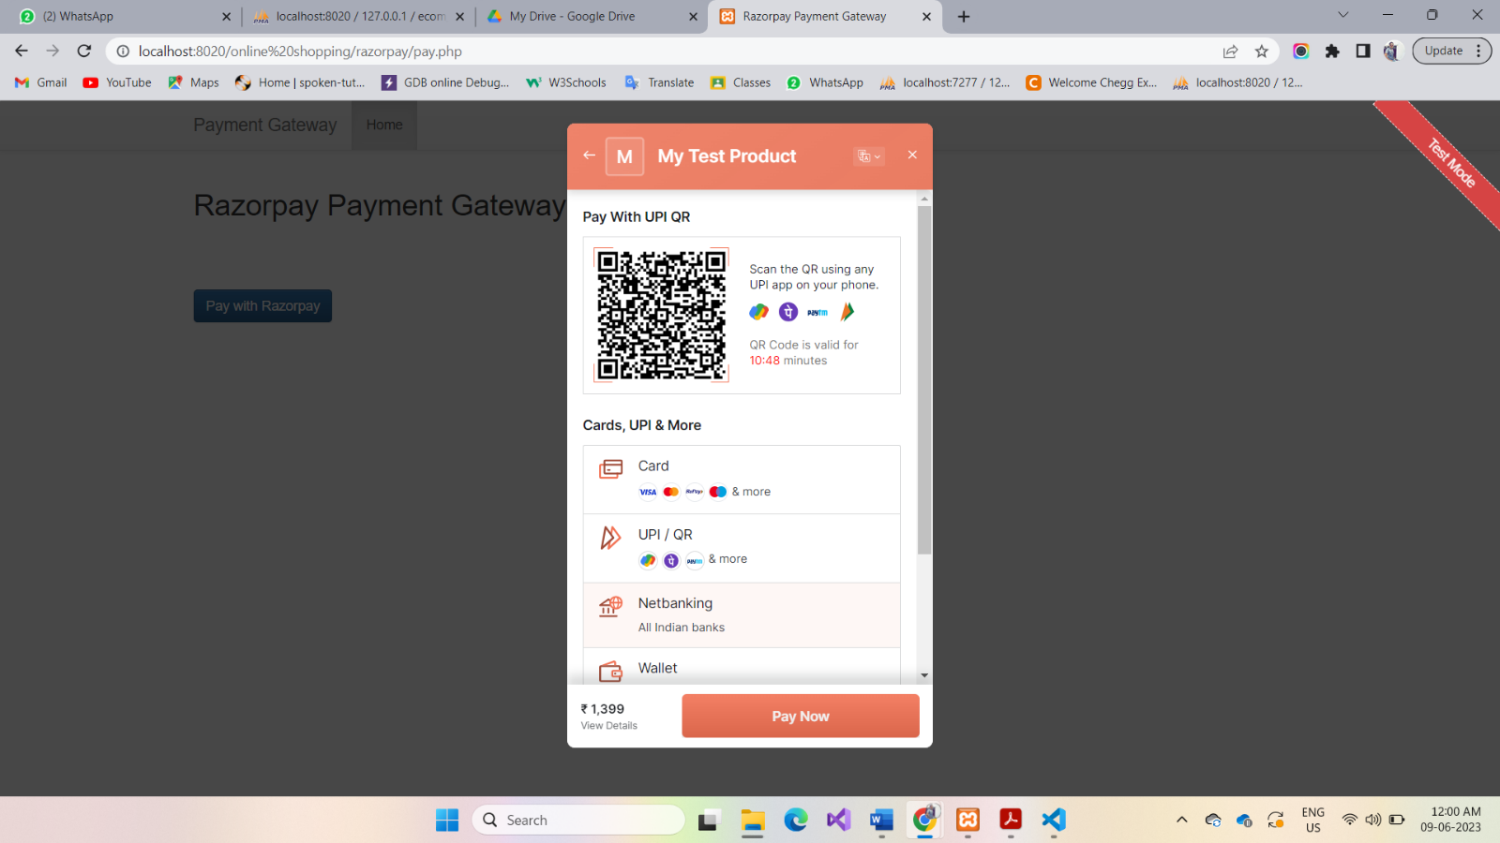

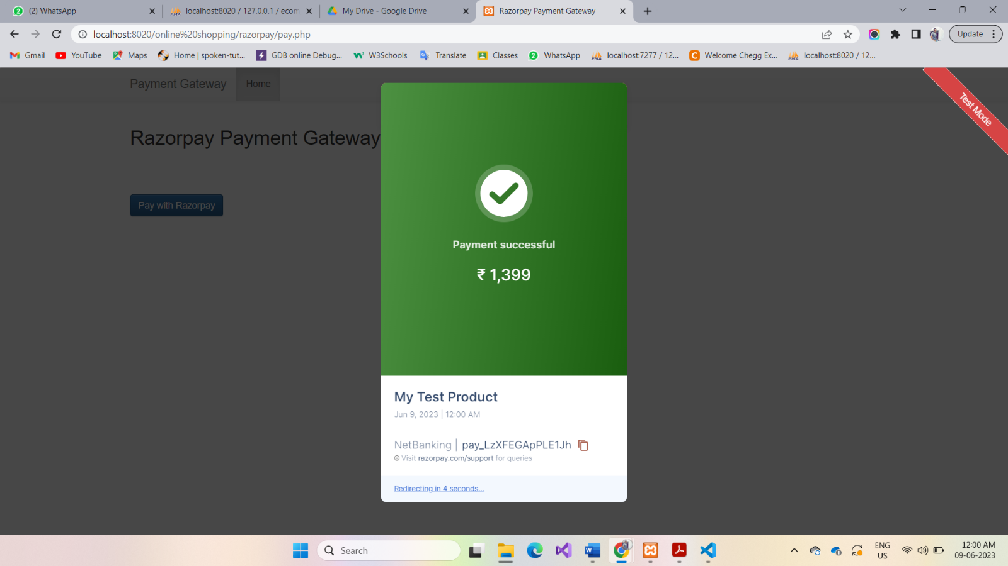

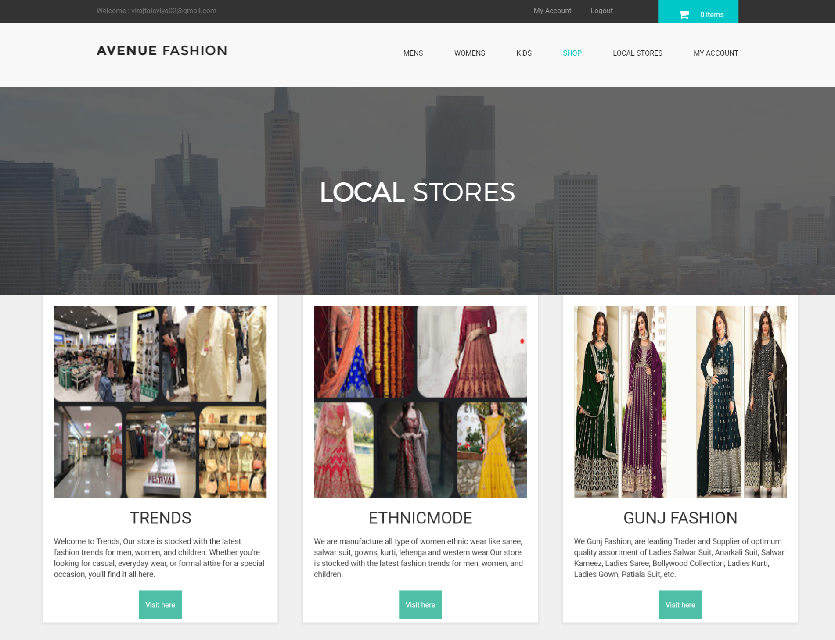

**\*Admin side\***

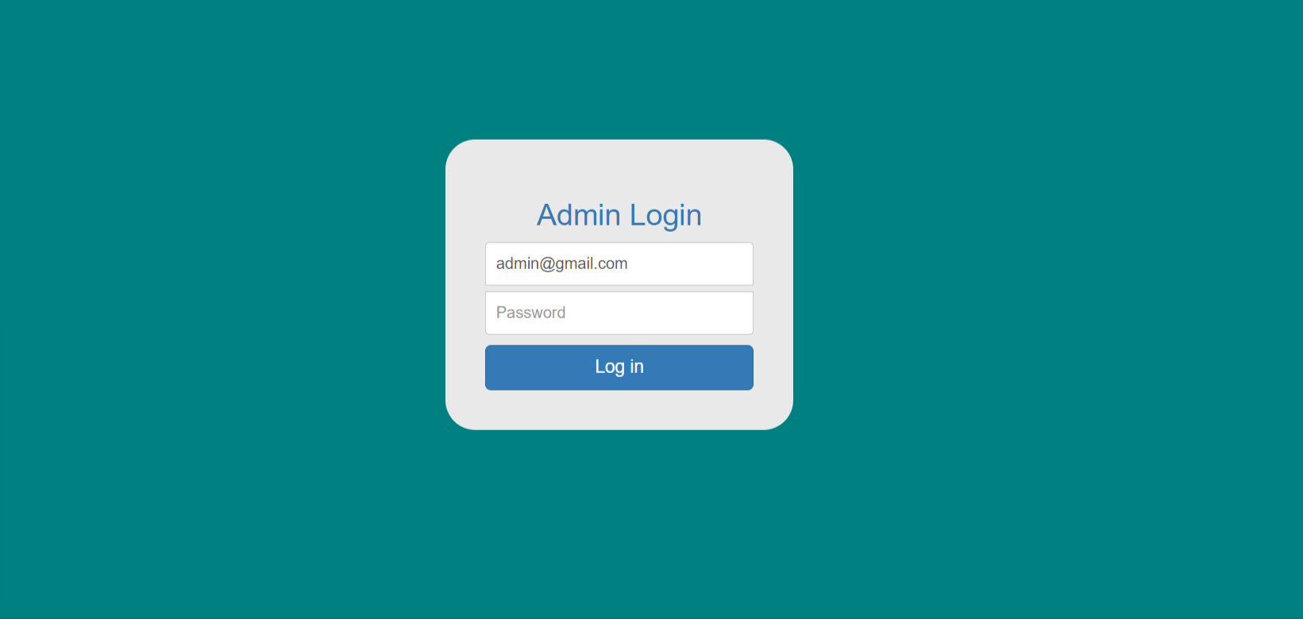

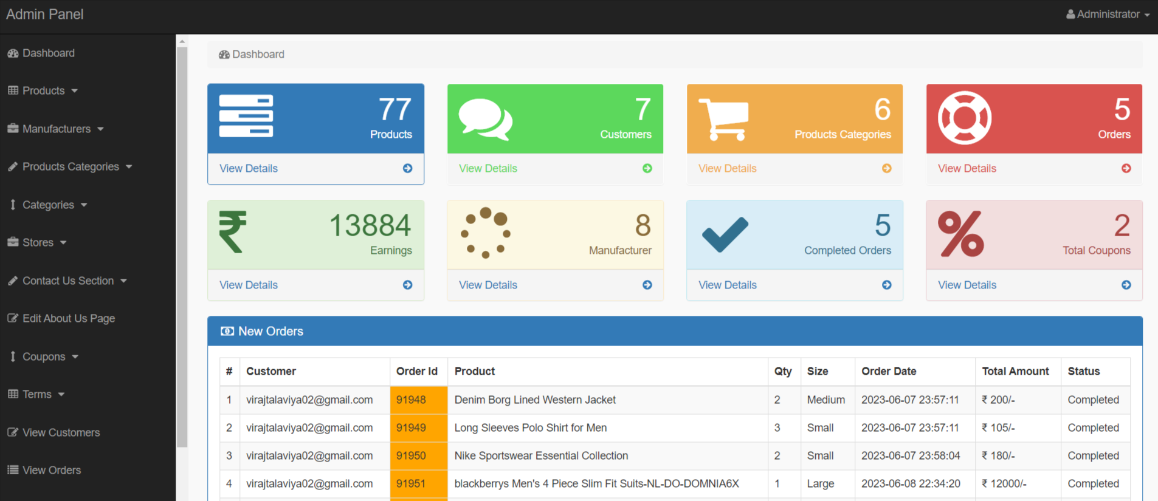**Dashboard**

**View Products**

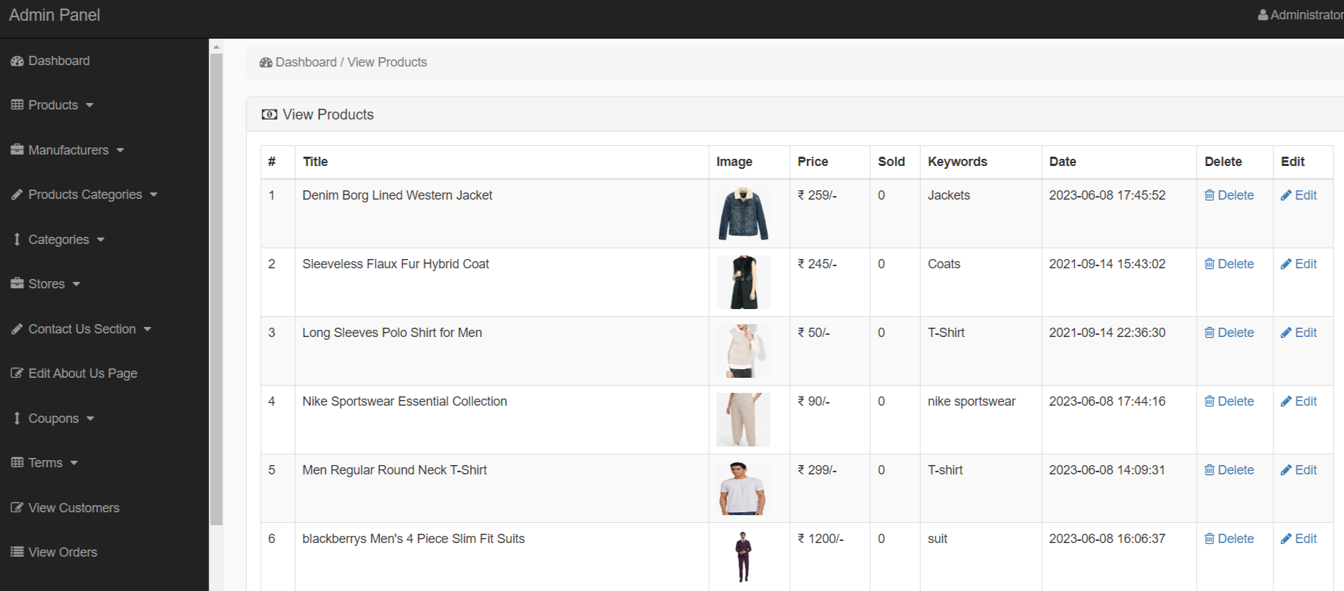

**View manufacturer**

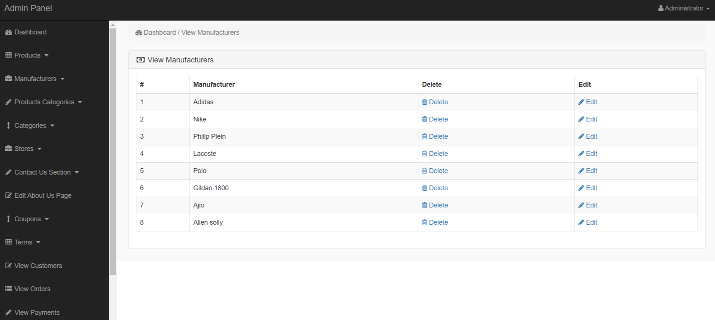

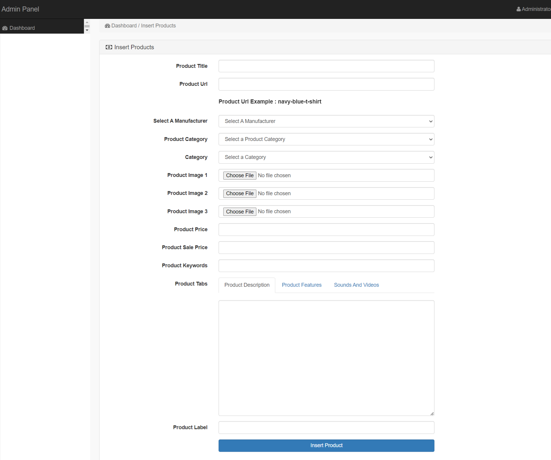**Insert Product**

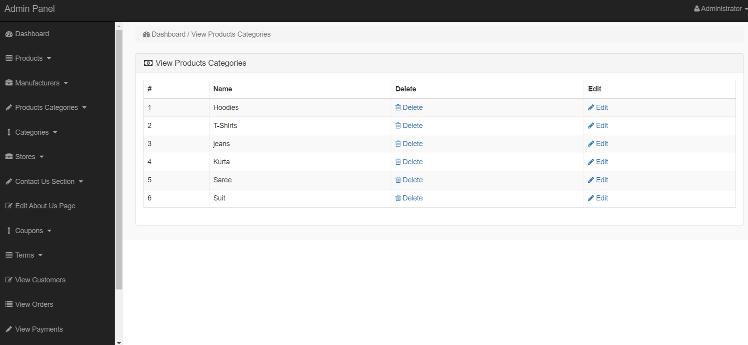**View product category**

**Manage Contact us page**

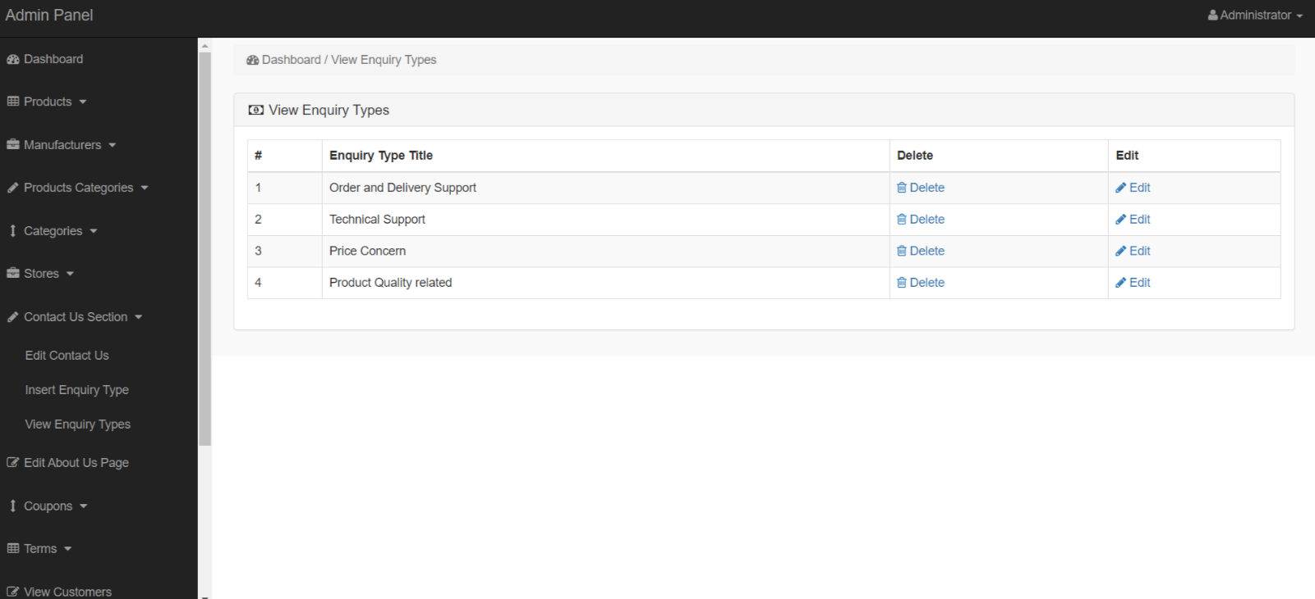

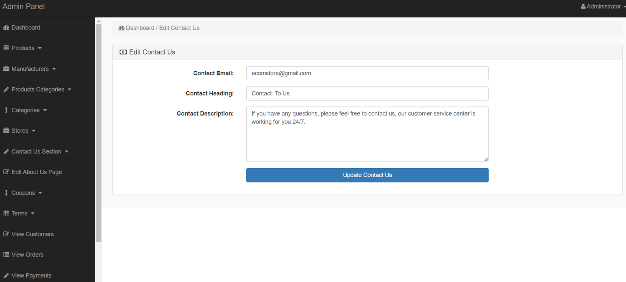

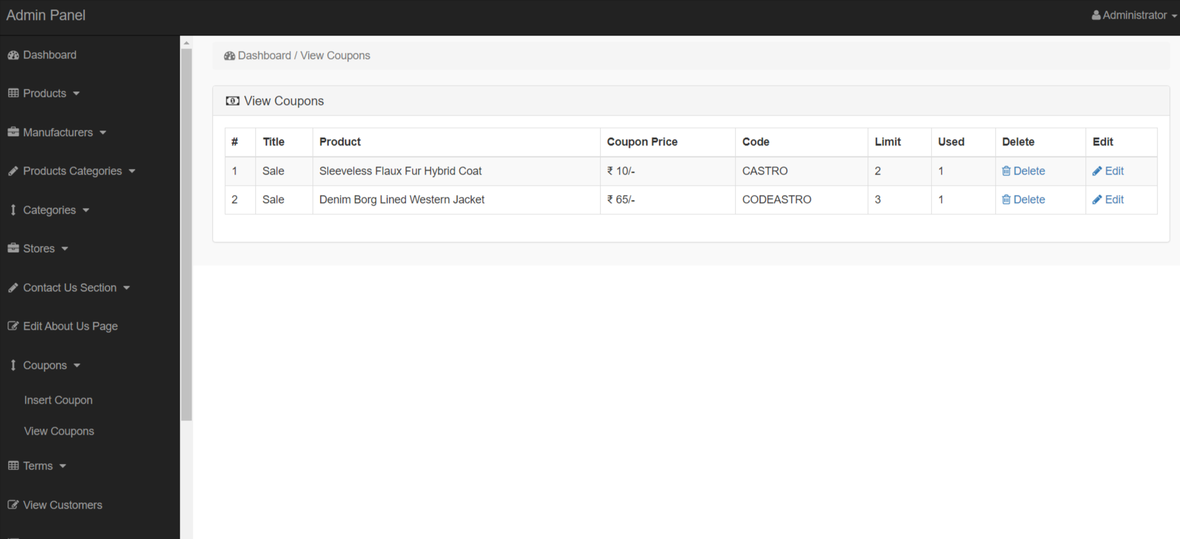**Manage Coupans**

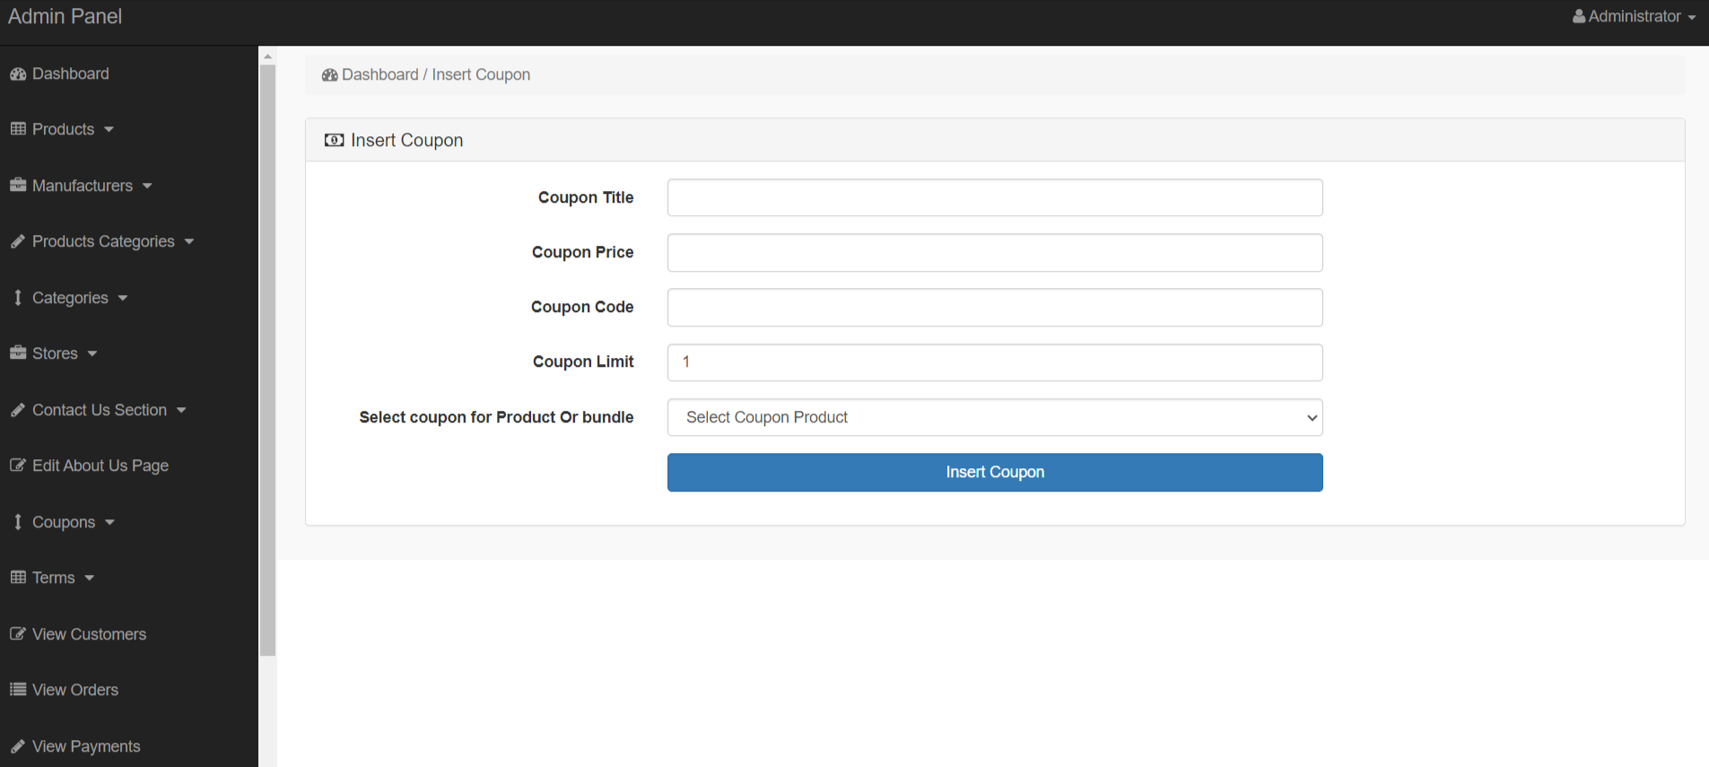

**Manage Terms**

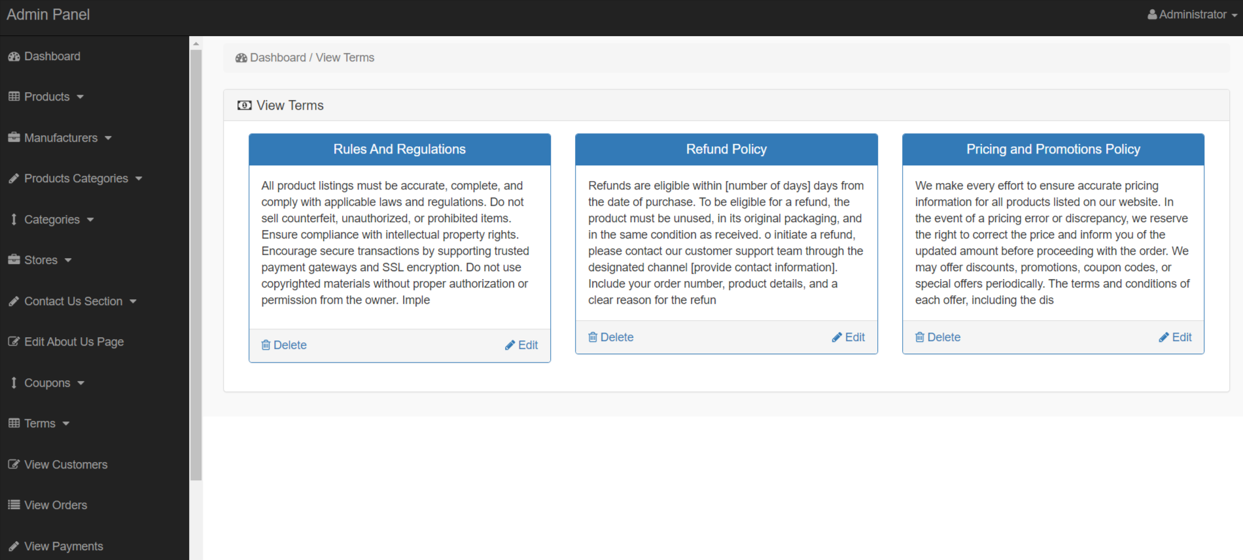

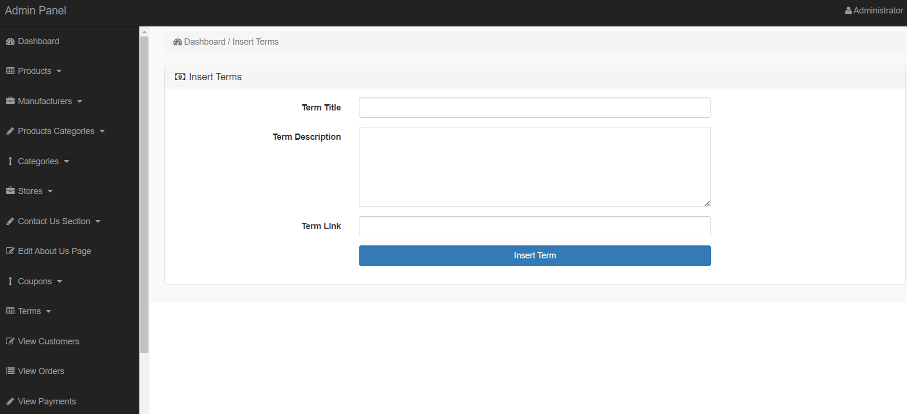

**View Customers**

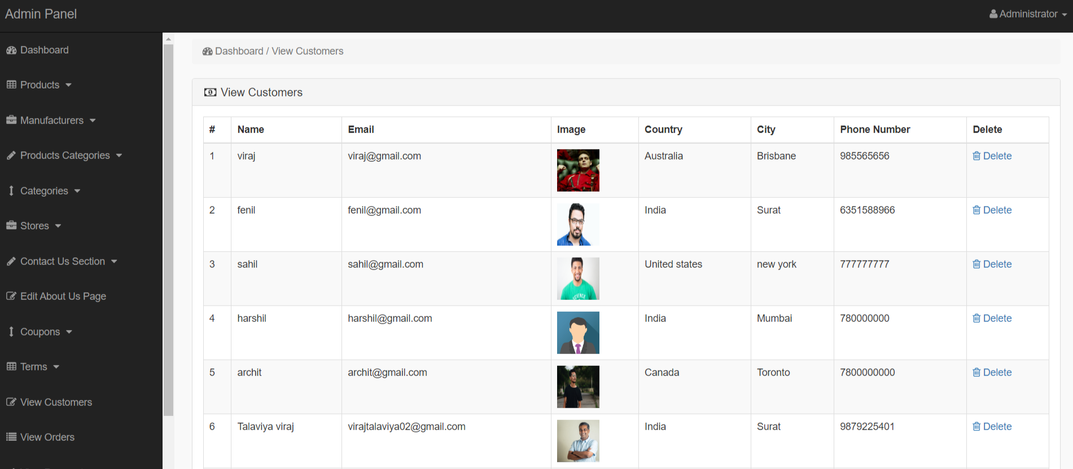

**View Orders**

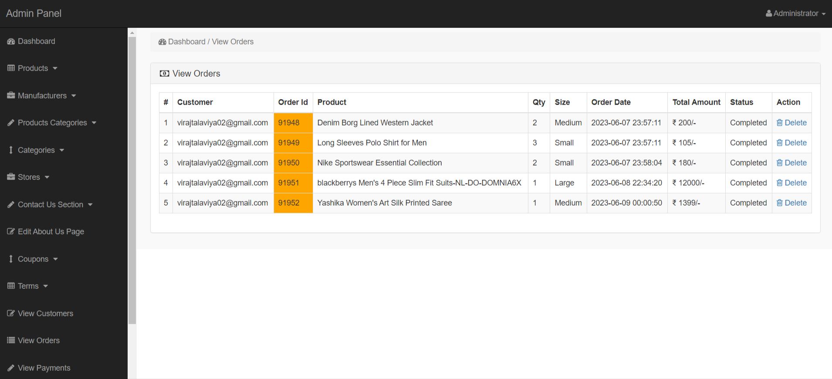

**View Payments**

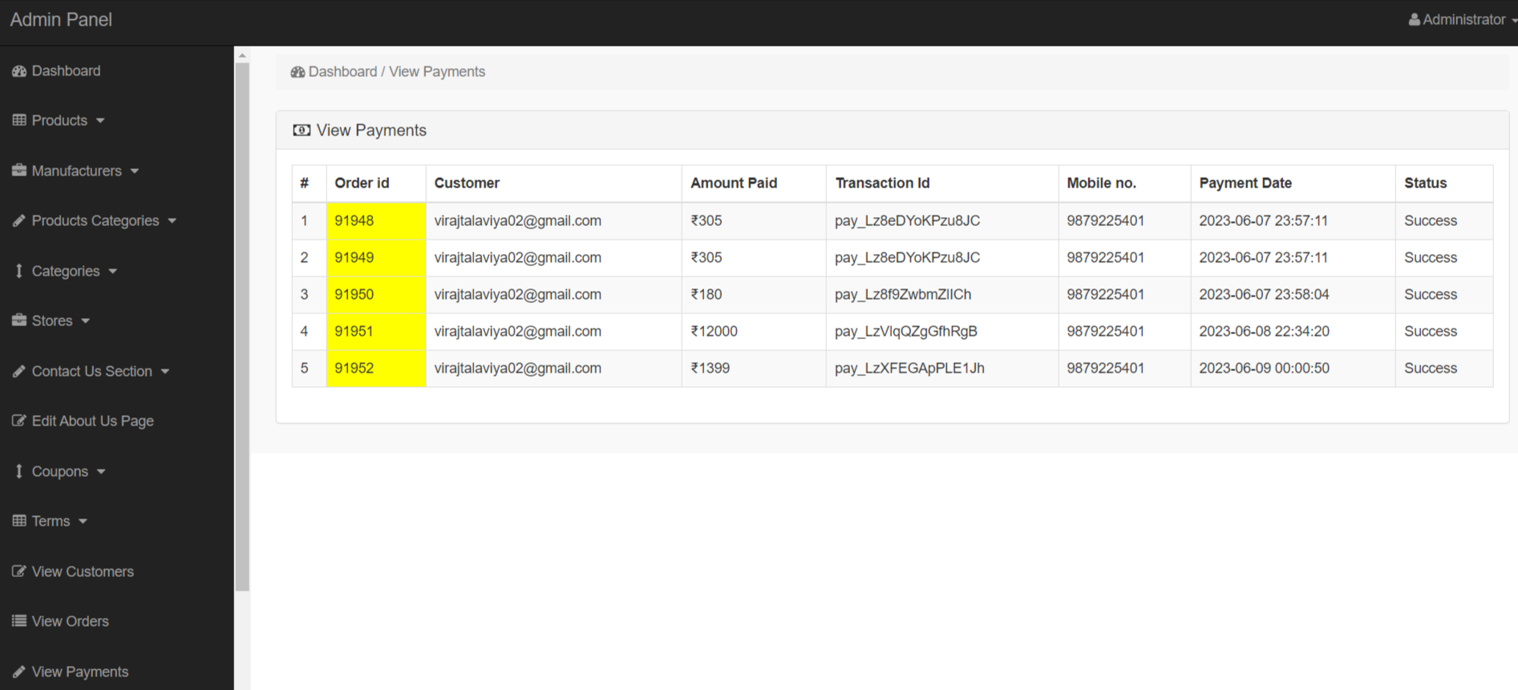

**Manage User**

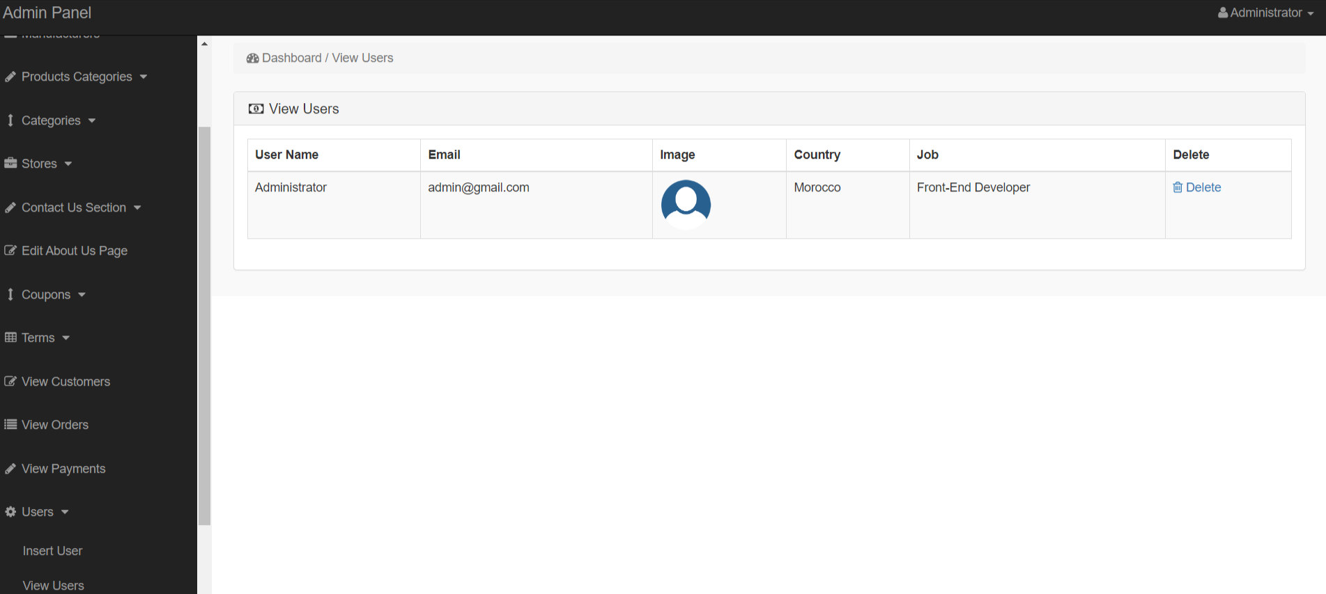

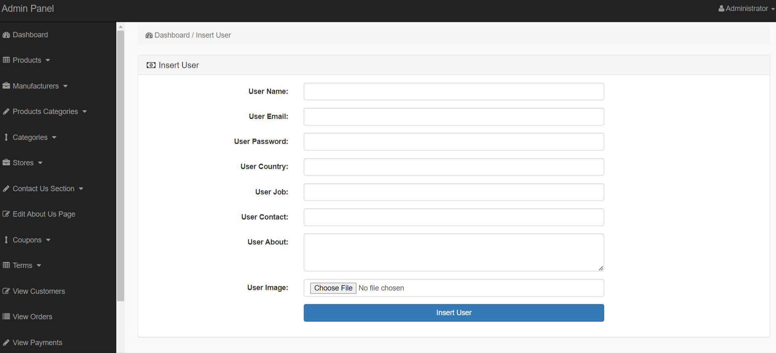





1. **SYSTEM TESTING**

|  |  |
| --- | --- |
| Process | Result |
| Administrative Site |  |
| * Manage User |  |
| * Add/Edit/Delete/View User | 1 |
| * Manage Dashboard |  |
| * View Manufacturer, Add Product, Add Category | 1 |
| * Manage Product |  |
| * Add/Edit/Delete/View Product | 1 |
| * Manage Account |  |
| * Add/Edit/Delete/View Admin, User | 1 |
| * Order |  |
| * View Order | 1 |
| * Payment |  |
| * View Payments | 1 |
| * Manage Stores/Coupans/Term |  |
| * Add/View Stores/Coupans/Term | 1 |
| * Principal Site |  |
| * Main Functions |  |
| * Login | 1 |
| * View Product | 1 |
| * View Categories | 1 |
| * View Cart | 1 |
| * View Payment | 1 |
| * View Order | 1 |
| * View Special Offers | 1 |
| * View Wishlist | 1 |
| * View Account | 1 |



**FUTURE ENHANCEMENT**

1. **FUTURE ENHANCEMENT**

* The field of software technology is constantly evolving. Developers have been compelled by this to find fresh methods of design and development. The modules in a package should always be upgraded to deal with this condition. The modules included in this bundle are upgradeable further. For example,
  + - created discussion forums.
    - Support for multimedia features.
    - Include course materials.



**REFERENCES**

**6.REFERENCES**

* <https://www.w3schools.com/>
* <https://getbootstrap.com/>
* <https://fontawesome.com/>
* <https://stackoverflow.com>
* <https://google.com>
* <https://yandex.com/>